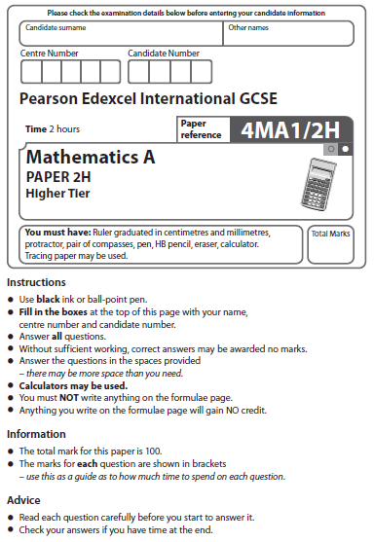
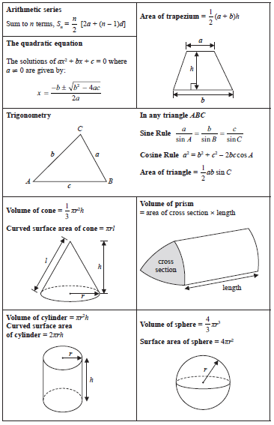

Answer ALL TWENTY SIX questions.
Write your answers in the spaces provided.
You must write down all the stages in your working.
1 Show that

(Total for Question 1 is 3 marks)
___________________________________________________________________________

2 Change a speed of 90 kilometres per hour to a speed in metres per second.
Show your working clearly.

...................................................... m/s
(Total for Question 2 is 3 marks)
___________________________________________________________________________

3 ℰ = {11, 12, 13, 14, 15, 16, 17, 18, 19, 20}

A = {even numbers}
A ∩ B = {12, 16, 20}
(A ∪ B)ʹ = {17, 19}

Complete the Venn diagram for the sets ℰ, A and B

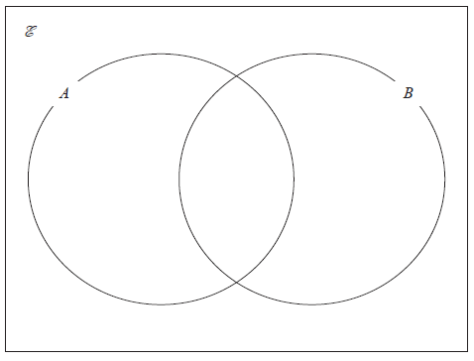

(Total for Question 3 is 3 marks)
___________________________________________________________________________

4 The diagram shows rectangle ABCD

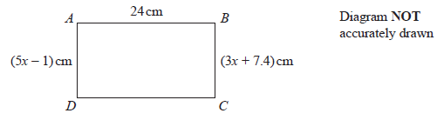

Work out the perimeter of the rectangle.
Show your working clearly.

...................................................... cm
(Total for Question 4 is 4 marks)
___________________________________________________________________________

5 The weight of a cake is 2.75 kg, correct to 2 decimal places.

(a) Write down the lower bound of the weight of the cake.

...................................................... kg
(1)
(b) Write down the upper bound of the weight of the cake.

...................................................... kg
(1)
Penny has worked out .
Her answer is 13 332.299 17
Penny’s answer is not sensible.
(c) By rounding each number to one significant figure, work out a suitable estimate to
show that her answer is not sensible.
Show your working clearly.

(2)
(Total for Question 5 is 4 marks)
___________________________________________________________________________

6 The points A and B are on a coordinate grid.
The coordinates of A are (6, 4)
The coordinates of B are (17, j) where j is a constant.
The midpoint of AB has coordinates (k, 15) where k is a constant.
Find the value of j and the value of k

j = ......................................................

k = ......................................................
(Total for Question 6 is 3 marks)
___________________________________________________________________________

7 Solve the simultaneous equations
5x + 4y = –2
2x – y = 4.4
Show clear algebraic working.

x = ......................................................

y = ......................................................
(Total for Question 7 is 3 marks)
___________________________________________________________________________

8 Matteo is going to invest 5000 Swiss francs for two years.
He can invest his money in Bank G or in Bank H.
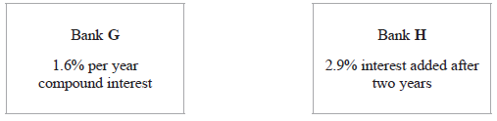

The total amount of interest Matteo would receive at the end of two years from
Bank G is more than the amount of interest Matteo would receive at the end of
two years from Bank H.

How much more?

...................................................... Swiss francs
(Total for Question 8 is 4 marks)
___________________________________________________________________________

9 (a) Write down the value of (m + 2)⁰ where m is a positive integer.

......................................................
(1)
(b) Simplify (3a²b⁴)³

......................................................
(2)
(c) Factorise fully 14x² y⁴ + 21x³ y²

..................................................................................
(2)
The diagram shows a straight line drawn on a grid.
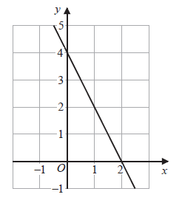
(d) Write down an equation of the line.

..................................................................................
(2)
(Total for Question 9 is 7 marks)
___________________________________________________________________________

10 The diagram shows an isosceles triangle, with base length 24 cm.
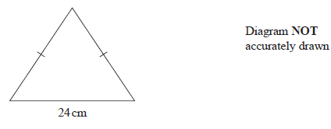
The perimeter of the triangle is 54 cm.
Work out the area of the triangle.

...................................................... cm²
(Total for Question 10 is 5 marks)
___________________________________________________________________________

11 Here are six graphs.

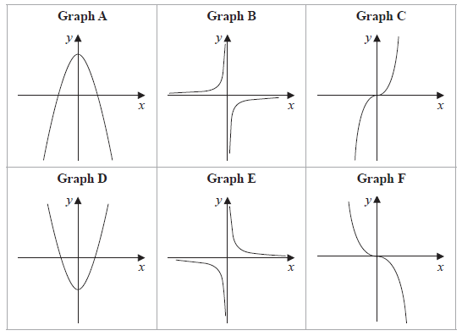
Complete the table below with the letter of the graph that could represent each
given equation.
Write your answers on the dotted lines.

Equation | Graph
 | .....................
y = 5 – x² | .....................
y = –2x³ | .....................

(Total for Question 11 is 3 marks)
___________________________________________________________________________

12 The cumulative frequency graph gives information about the time, in minutes, each of
60 people took to shop in a market.

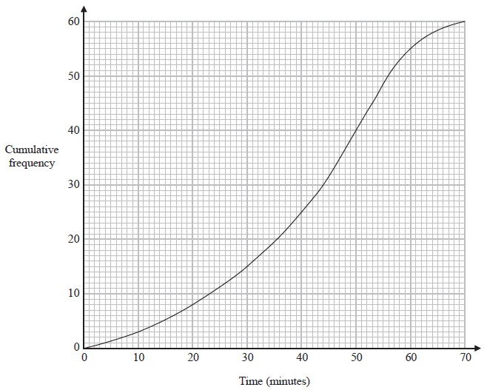

(a) Use the graph to find an estimate for the median time people took to shop in
the market.

...................................................... minutes
(1)
(b) Use the graph to find an estimate for the number of people who took longer than
55 minutes to shop in the market.

......................................................
(2)
(c) Use the graph to complete the frequency table to give information about the time,
in minutes, each of the 60 people took to shop in the market.

Time taken to shop in the market  (m minutes) | Frequency
0 < m ≤ 10 | 3
10 < m ≤ 20 | 5
20 < m ≤ 30
30 < m ≤ 40
40 < m ≤ 50
50 < m ≤ 60
60 < m ≤ 70
(2)
(Total for Question 12 is 5 marks)
___________________________________________________________________________

13 Solve
Show clear algebraic working.

x = ......................................................
(Total for Question 13 is 3 marks)
___________________________________________________________________________

14 A, B, C and D are points on a circle, centre O
EBF is the tangent to the circle at B

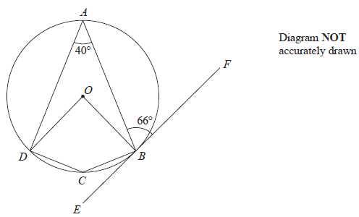

(a) (i) Work out the size of angle DCB
......................................................°
(1)
(ii) Give a reason for your answer to (a)(i)

......................................................................................................................................................

......................................................................................................................................................
(1)
(b) Work out the size of angle ADO

......................................................°
(3)
(Total for Question 14 is 5 marks)
___________________________________________________________________________

15 Here is a list giving the numbers of runs scored last week by the eleven members of
cricket team A.

2 | 3 | 4 | 6 | 21 | 26 | 27 | 32 | 34 | 61 | 72

The interquartile range of the numbers of runs scored last week by the eleven members
of cricket team B was 42

Using a suitable calculation, write down one comparison between the numbers of runs
scored by the members of cricket team A and the members of cricket team B.
Show your working clearly.

......................................................................................................................................................

......................................................................................................................................................
(Total for Question 15 is 3 marks)
___________________________________________________________________________

16 Use algebra to show that

(Total for Question 16 is 2 marks)
___________________________________________________________________________
17 Given that
where k is an integer and m is a prime number,
(a) work out the value of k

k = ......................................................
(1)
(b) Show that can be written in the form
where a and b are integers.
Show each stage of your working clearly.

(3)
(Total for Question 17 is 4 marks)
___________________________________________________________________________

18 The table gives information about the weights, in kg, of the parcels that Pedro delivers
on Monday.

Weight (w kg) | Frequency
0 < w ≤ 2 | 12
2 < w ≤ 3 | 7
3 < w ≤ 6 | 15
6 < w ≤ 9 | 12
9 < w ≤ 14 | 9

(a) On the grid, draw a histogram for this information.
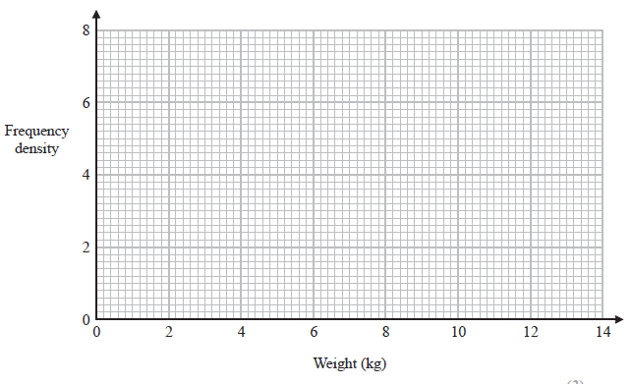
(3)
One of the parcels that Pedro delivered on Monday is chosen at random.
(b) Using the information in the table, find an estimate for the probability that this
parcel weighs more than 7 kg.

......................................................
(2)
(Total for Question 18 is 5 marks)
___________________________________________________________________________

19 A and B are two similar vases.
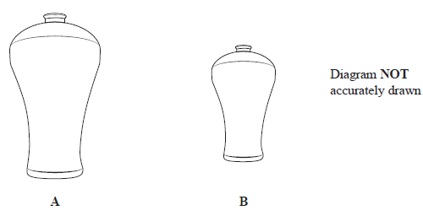
The vases are such that

surface area of vase B = surface area of vase A
and that

volume of vase A – volume of vase B = 541.8 cm³

Calculate the volume of vase B

...................................................... cm³
(Total for Question 19 is 4 marks)
___________________________________________________________________________
20 Solve the simultaneous equations

y = 7 – 2x
x² + y² = 34

Show clear algebraic working.

..........................................................................................................................
(Total for Question 20 is 5 marks)
___________________________________________________________________________

21 Given that the surface area of a sphere is 49π cm²
find the volume of the sphere.
Give your answer correct to the nearest integer.

...................................................... cm³
(Total for Question 21 is 3 marks)
___________________________________________________________________________

22 Solve the inequality 6x² + 37x ≤ 35
Show clear algebraic working.

..................................................................................
(Total for Question 22 is 3 marks)
___________________________________________________________________________

23 The diagram shows a solid prism ABCDEFGHIJ

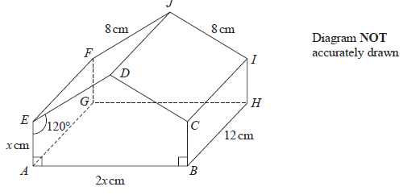

The prism is such that each cross section is a pentagon where

AE = BC = x cm AB = 2x cm ED = CD = 8 cm

angle EAB = angle CBA = 90° angle AED = angle BCD = 120°

Given that AG = BH = EF = DJ = CI = 12 cm

calculate the angle that AJ makes with the base ABHG of the prism.
Give your answer correct to 3 significant figures.

......................................................°
(Total for Question 23 is 5 marks)
___________________________________________________________________________

24 The graph of y = a sin x° + b is drawn on the grid.

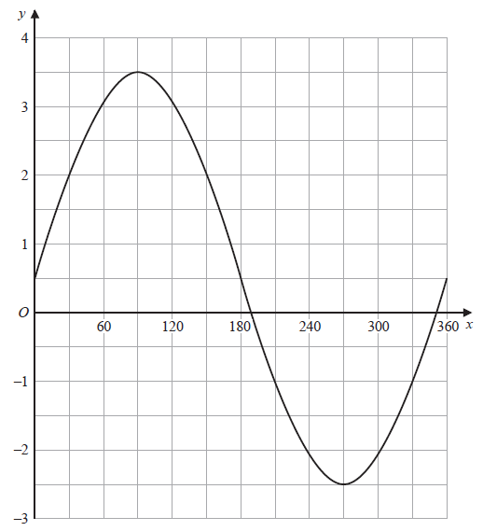

Find the value of a and the value of b

a = ......................................................

b = ......................................................
(Total for Question 24 is 2 marks)
___________________________________________________________________________

25 The function f is such that f(x) = 3x² – 12x + 7 where x ≤ 2

Express the inverse function f ^{–1} in the form f ^{–1}(x) = …

f ^{–1}(x) = ......................................................
(Total for Question 25 is 4 marks)
___________________________________________________________________________

26 Find the values of n such that

Show clear algebraic working.
......................................................
(Total for Question 26 is 5 marks)
___________________________________________________________________________
TOTAL FOR PAPER IS 100 MARKS

