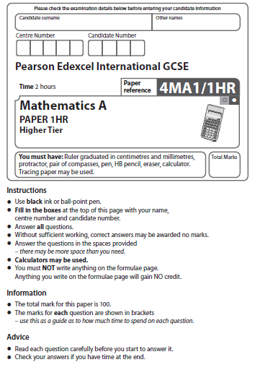
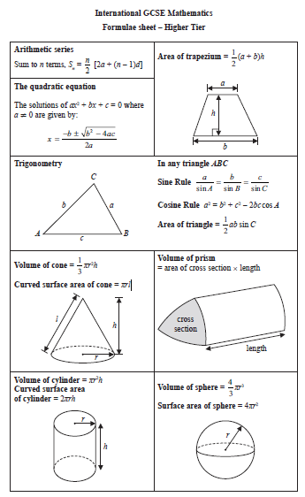Answer ALL TWENTY FOUR questions.
Write your answers in the spaces provided.
You must write down all the stages in your working.
1 The table shows information about the frame size, in cm, of 60 bicycles sold in a shop.

Frame size (S cm) | Frequency
30 < S ≤ 36 | 4
36 < S ≤ 42 | 14
42 < S ≤ 48 | 18
48 < S ≤ 54 | 19
54 < S ≤ 60 | 5

(a) Write down the modal class.

......................................................
(1)
(b) Work out an estimate for the mean frame size.

...................................................... cm
(4)
(Total for Question 1 is 5 marks)
___________________________________________________________________________
2 The diagram shows a solid triangular prism.

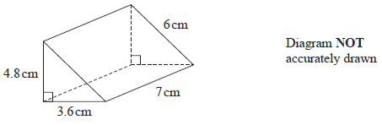

Work out the total surface area of the triangular prism.
Give your answer correct to 3 significant figures.

...................................................... cm²
(Total for Question 2 is 3 marks)
___________________________________________________________________________

3 Here is a list of six numbers written in order of size.

x | 5 | y | z | 10 | 12
The numbers have
a range of 9
a median of 8
a mode of 10

Find the value of x, the value of y and the value of z

x = ......................................................

y = ......................................................

z = ......................................................
(Total for Question 3 is 3 marks)
___________________________________________________________________________

4 Divya and Yuan each pay for a holiday at a special offer price.

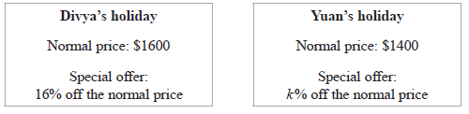
The amount that Divya pays is the same as the amount that Yuan pays.

Work out the value of k

k = ......................................................
(Total for Question 4 is 4 marks)
___________________________________________________________________________

5 C grams of chocolate is shared in the ratios 2 : 5 : 8
The difference between the largest share and the smallest share is 390 grams.

Work out the value of C

C = ......................................................
(Total for Question 5 is 3 marks)
___________________________________________________________________________

6 Solve the simultaneous equations

x + 2y = 15
4x – 6y = 4

Show clear algebraic working.

x = ......................................................

y = ......................................................
(Total for Question 6 is 3 marks)
___________________________________________________________________________
7 (a) Write 9.32 × 10^{–5} as an ordinary number.

..................................................................................
(1)
(b) Work out 3 × 10⁵ – 6 × 10⁴
Give your answer in standard form.

..................................................................................
(2)
(c) Work out (3 × 10⁵⁵) × (6 × 10⁶⁵)
Give your answer in standard form.

..................................................................................
(2)
(Total for Question 7 is 5 marks)
___________________________________________________________________________

8 (a) Factorise fully 18c³d² – 21c²

......................................................
(2)
(b) (i) Factorise y² – 3y – 18

......................................................
(2)
(ii) Hence, solve y² – 3y – 18 = 0

......................................................
(1)
(Total for Question 8 is 5 marks)
___________________________________________________________________________

9 The diagram shows an isosceles triangle ABC

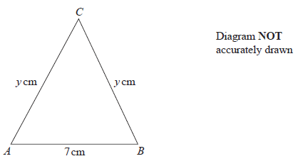

AB = 7 cm AC = BC = y cm

The area of the triangle is 42 cm²

Work out the value of y

y = ......................................................
(Total for Question 9 is 4 marks)
___________________________________________________________________________

10 R and T are points on a circle, centre O

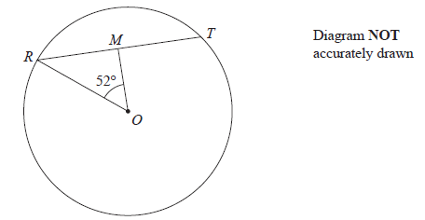

RT = 12 cm
M is the midpoint of RT
Angle ROM = 52°
Work out the area of the circle.
Give your answer correct to 3 significant figures.

...................................................... cm²
(Total for Question 10 is 4 marks)
___________________________________________________________________________

11 The table shows information about the times, in minutes, that 80 patients had to wait to
see a doctor.

Time (W minutes) | Frequency
0 < W ≤ 10 | 7
10 < W ≤ 20 | 10
20 < W ≤ 30 | 15
30 < W ≤ 40 | 32
40 < W ≤ 50 | 16

(a) Complete the cumulative frequency table below.

Time (W minutes) | Cumulative frequency
0 < W ≤ 10
10 < W ≤ 20
20 < W ≤ 30
30 < W ≤ 40
40 < W ≤ 50
(1)
(b) On the grid on the next page, draw a cumulative frequency graph for your table.

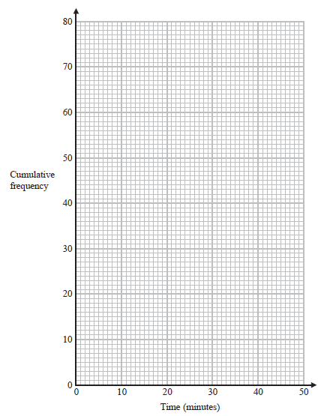
(2)
(c) Use your graph to find an estimate for the median.

...................................................... minutes
(1)
(d) Use your graph to find an estimate for the interquartile range.

...................................................... minutes
(2)
(Total for Question 11 is 6 marks)
___________________________________________________________________________

12 Solve 2^{–4x} = 32

x = ......................................................
(Total for Question 12 is 2 marks)
___________________________________________________________________________

13 Use algebra to show that

(Total for Question 13 is 2 marks)
___________________________________________________________________________

14

p = 0.51 correct to 2 significant figures.
r = 6.3 correct to 2 significant figures.
Work out the upper bound for the value of T
Show your working clearly.

......................................................
(Total for Question 14 is 2 marks)
___________________________________________________________________________

15 (a) Complete the table of values for y = x³ – 3x + 2

x | –2 | –1 | –0.5 | 0 | 1 | 1.5 | 2
y |  | 4 | 3.4 |  | 0 | 0.9
(2)

(b) On the grid, draw the graph of y = x³ – 3x + 2 for values of x from –2 to 2
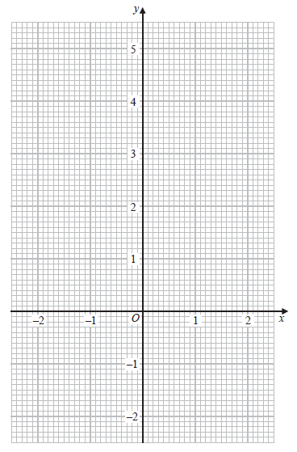
(2)

(c) By drawing a suitable straight line on the grid, use your graph to find an estimate for
the solution of

2x³ – 3x + 4 = 0

Give your answer correct to one decimal place.

......................................................
(3)
(Total for Question 15 is 7 marks)
___________________________________________________________________________

16 The function f is such that

(a) Find

......................................................
(1)
(b) Find f ^{–1}(x)

f ^{–1}(x) = ......................................................
(2)
The function g is such that

g(x) = 5x² – 20x + 23

(c) Express g(x) in the form a(x – b)² + c

......................................................
(3)
(Total for Question 16 is 6 marks)
___________________________________________________________________________
17
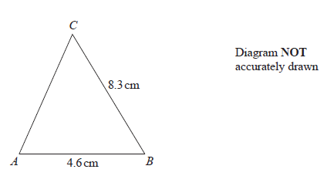
AB = 4.6 cm BC = 8.3 cm angle ABC is acute
The area of triangle ABC is 12 cm²
Work out the perimeter of triangle ABC
Give your answer correct to 3 significant figures.

...................................................... cm
(Total for Question 17 is 5 marks)
___________________________________________________________________________
18 Solve

Give your answer in the form where a and b are integers.
Show your working clearly.

x = ......................................................
(Total for Question 18 is 4 marks)
___________________________________________________________________________

19 P is inversely proportional to y²
When y = 4, P = a

(a) Find a formula for P in terms of y and a

......................................................
(3)
Given also that y is directly proportional to x
and when x = a, P = 4a

(b) find a formula for P in terms of x and a

......................................................
(3)
(Total for Question 19 is 6 marks)
___________________________________________________________________________

20 Here is a sketch of the curve y = a cos(x + b)° for 0 ≤ x ≤ 360
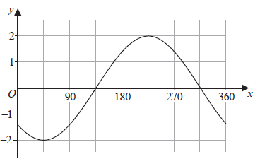
Given that 0 < b < 180
find the value of a and the value of b

a = ......................................................

b = ......................................................
(Total for Question 20 is 2 marks)
___________________________________________________________________________

21 The diagram shows a triangular prism, ABCDEF, with a rectangular base ABCD
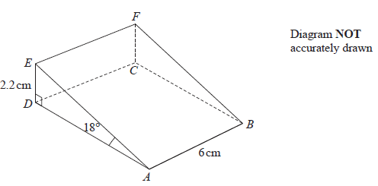
AB = 6 cm DE = 2.2 cm angle DAE = 18° angle ADE = 90°
Work out the angle that BE makes with the plane ABCD
Give your answer correct to one decimal place.

......................................................°
(Total for Question 21 is 4 marks)
___________________________________________________________________________

22 The diagram shows triangle OAB with OA extended to E
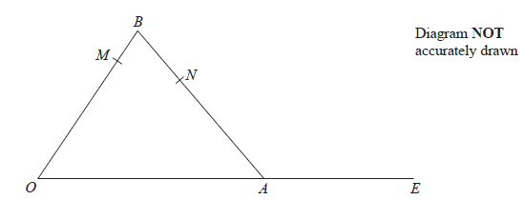

M is the point on OB such that OM : MB = 4 : 1
N is the point on AB such that AN : NB = 3 : 2
OA : AE = 5 : 3

(a) Find an expression for in terms of a and b
Give your answer in its simplest form.

= ......................................................
(2)

(b) Use a vector method to show that MNE is a straight line.

(3)
(Total for Question 22 is 5 marks)
___________________________________________________________________________

23 G is the point on the curve with equation y = 8x² – 14x – 6 where the gradient is 10
The straight line Q passes through the point G and is perpendicular to the tangent at G
Find an equation for Q
Give your answer in the form ax + by + c = 0 where a, b and c are integers.

..................................................................................
(Total for Question 23 is 5 marks)
___________________________________________________________________________

24 An arithmetic sequence has first term 8 and common difference 11
The sequence has k terms, where k > 21
The sum of the last 20 terms of the sequence is 10 170
Find the value of k
Show clear algebraic working.

k = ......................................................
(Total for Question 24 is 5 marks)
___________________________________________________________________________
TOTAL FOR PAPER = 100 MARKS

