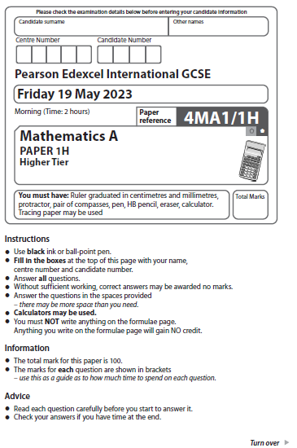
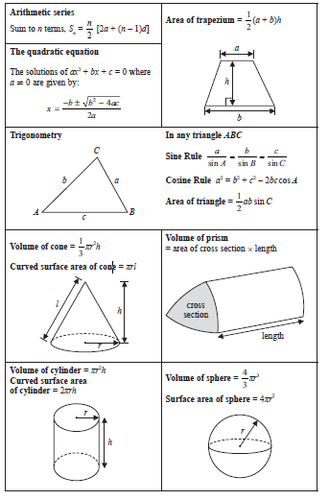
Answer ALL TWENTY THREE questions.
Write your answers in the spaces provided.
You must write down all the stages in your working.
1 Last season, the number of goals scored by Arjun, by Simon and by Kath for their
football team were in the ratios 2 : 5 : 8
Simon scored 12 more goals than Arjun.
Work out the number of goals scored by Kath.

.......................................................
(Total for Question 1 is 3 marks)
___________________________________________________________________________

2 The table gives information about the number of minutes that Abby spent walking each
day in September.

Number of minutes (M) | Frequency
0 < M ≤ 30 | 5
30 < M ≤ 60 | 6
60 < M ≤ 90 | 8
90 < M ≤ 120 | 9
120 < M ≤ 150 | 2

Work out an estimate for the total number of minutes that Abby spent walking
in September.

....................................................... minutes
(Total for Question 2 is 3 marks)
___________________________________________________________________________

3 Nanette buys 60 notebooks for a total cost of 780 dirhams.
Nanette sells 70% of the notebooks for 22 dirhams each.
She sells the remaining notebooks for 19 dirhams each.
Work out Nanette’s percentage profit.
Give your answer correct to 3 significant figures.

.......................................................%
(Total for Question 3 is 4 marks)
___________________________________________________________________________

4 The diagram shows a sketch of triangle A and triangle B on a coordinate grid.

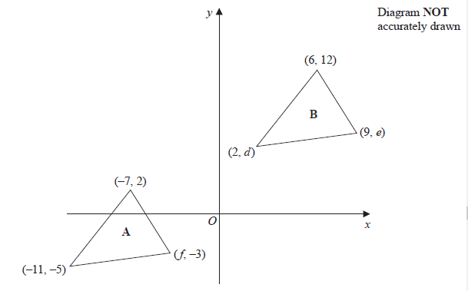

(a) Given that triangle A has been translated to give triangle B, work out the value of d,
the value of e and the value of f

d = .......................................................

e = .......................................................

f = .......................................................
(3)

The diagram shows shape P and shape Q drawn on a grid.

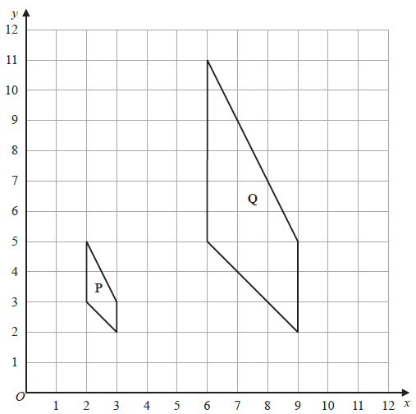

(b) Describe fully the single transformation that maps shape P onto shape Q

......................................................................................................................................................

......................................................................................................................................................(3)
(c) On the grid above, rotate shape P 90° clockwise about (3, 5)
Label your shape R

(2)
(Total for Question 4 is 8 marks)
___________________________________________________________________________

5 The diagram shows a shaded shape AEBCD made by removing triangle AEB from
rectangle ABCD
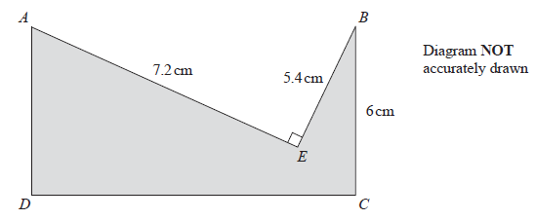
AE = 7.2 cm BE = 5.4 cm BC = 6 cm AEB = 90°

Work out the perimeter of the shaded shape.

....................................................... cm
(Total for Question 5 is 4 marks)
___________________________________________________________________________

6 (a) Simplify (2c⁴ d ⁷)³

.......................................................
(2)
(b) Find the value of 5y⁰ where y > 0

.......................................................
(1)
(c) Factorise fully 16a²b³ + 20a³b

.......................................................
(2)
(d) (i) Factorise x² + 9x – 22

.......................................................
(2)
(ii) Hence solve x² + 9x – 22 = 0

.......................................................
(1)
(Total for Question 6 is 8 marks)
___________________________________________________________________________

7
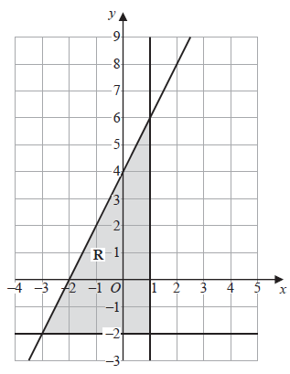

The region R, shown shaded in the diagram, is bounded by three straight lines.

Find the inequalities that define R

.......................................................

.......................................................

.......................................................
(Total for Question 7 is 4 marks)
___________________________________________________________________________
8 (a) Write 300 as a product of its prime factors.
Show your working clearly.

.......................................................
(2)
A = 2 × 2 × 2 × 3 × 3 × 5
B = 2 × 2 × 3 × 3 × 3 × 5
(b) Find the lowest common multiple (LCM) of 5A and 7B
Show your working clearly.

.......................................................
(2)
(Total for Question 8 is 4 marks)
___________________________________________________________________________
9 Solve the simultaneous equations
2x + 9y = 14.5
7x + 3y = 8
Show clear algebraic working.

x = .......................................................

y = .......................................................
(Total for Question 9 is 3 marks)
__________________________________________________________________________

10 Here are the test marks of 15 students.

7 | 10 | 14 | 15 | 16 | 17 | 18 | 19 | 20 | 20 | 23 | 25 | 30 | 39 | 40

Find the interquartile range of these marks.

.......................................................
(Total for Question 10 is 2 marks)
___________________________________________________________________________

11 The curve C has equation y = 4x³ + x² – 20x
(a) Find

= .......................................................
(2)
(b) Find the x coordinates of the points on C where the gradient is 4
Show clear algebraic working.

.......................................................
(4)
(Total for Question 11 is 6 marks)
___________________________________________________________________________

12 The cumulative frequency graph shows information about the heights, in centimetres,
of 50 plants in a flowerbed.
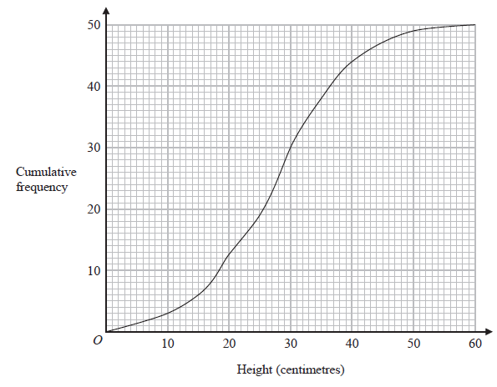(a) Use the graph to find an estimate for the median height of these plants.

....................................................... centimetres
(1)
(b) Use the graph to find the frequency for the class interval 30 < Height ≤ 40

.......................................................
(1)
(c) Use the graph to find an estimate for the number of plants with a height greater than
35 centimetres.

.......................................................
(2)
(Total for Question 12 is 4 marks)
___________________________________________________________________________
13 A is the point with coordinates (–5, 12)
B is the point with coordinates (19, –48)
Find an equation of the straight line that passes through the points A and B

.......................................................
(Total for Question 13 is 3 marks)
___________________________________________________________________________

14 Factorise fully 50g² – 18

.......................................................
(Total for Question 14 is 3 marks)
___________________________________________________________________________

15 (a)

Work out the value of n
Show your working clearly.

n = .......................................................
(3)
(b) Find 4% of 4.5 × 10¹⁵⁷
Give your answer in standard form.

.......................................................
(3)
(Total for Question 15 is 6 marks)
___________________________________________________________________________

16 The Venn diagram shows a universal set E and sets A, B and C

The numbers and the letter x represent numbers of elements.
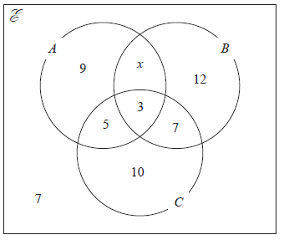

Given that n(A ∪ B) = 42
(a) find the value of x

x = .......................................................
(1)
(b) Find n(Aʹ)

.......................................................
(1)
(c) Find n(Bʹ ∩ C)

.......................................................
(1)
(Total for Question 16 is 3 marks)
___________________________________________________________________________

17 The functions g and h are such that
h(x) = x² + 4 x ≥ 0
(a) What value of x must be excluded from any domain of g?

.......................................................
(1)
(b) Solve gh(x) = 1

.......................................................
(3)
(Total for Question 17 is 4 marks)
___________________________________________________________________________

18 The incomplete table and incomplete histogram give information about the times,
in minutes, that 140 people waited at a station for a train.

Time (t minutes) | Frequency
0 < t ≤ 5 | 23
5 < t ≤ 15
15 < t ≤ 30
30 < t ≤ 40 | 18
40 < t ≤ 60 | 14

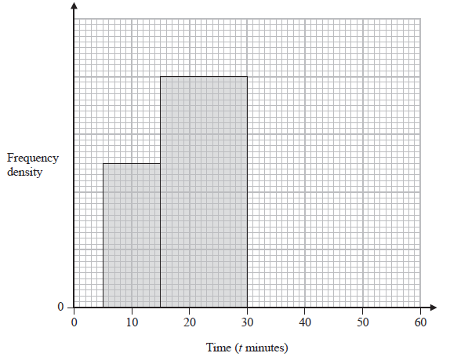
Complete the table and the histogram.

Total for Question 18 is 4 marks)
___________________________________________________________________________

19
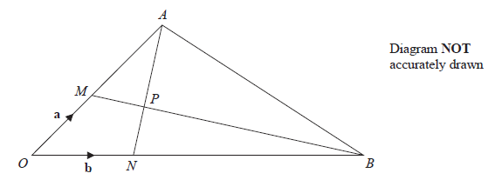

OMA, ONB, MPB and NPA are straight lines.
M is the midpoint of OA
ON : NB = 1 : 5

= a = b

(a) Find in terms of a and b the vector

.......................................................
(1)
(b) Use a vector method to find the ratio AP : PN

AP : PN = .......................................................
(4)
(Total for Question 19 is 5 marks)
___________________________________________________________________________

20 The sum of the first 80 terms of an arithmetic series, S, is 470
The 75th term of S is 14.5
The sum of the first X terms of S is 171
Work out the value of X
Show your working clearly.

X = .......................................................
(Total for Question 20 is 6 marks)
___________________________________________________________________________

21 A curve has equation y = f(x)
There is only one turning point on the curve.
The coordinates of this turning point are (6, 5)
Write down the coordinates of the turning point on the curve with equation
(a) y = f(x – 4)

(............................ , ............................)
(1)
(b) y = f(3x)

(............................ , ............................)
(1)
(Total for Question 21 is 2 marks)
___________________________________________________________________________

22 The diagram shows two circles with centre O and a regular pentagon ABCDE
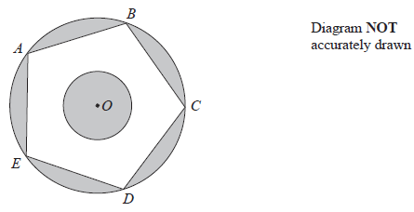

A, B, C, D and E are points on the larger circle.
The pentagon has sides of length 8 cm.

The diagram is shaded such that

shaded area = unshaded area

Work out the radius of the smaller circle.
Give your answer correct to 3 significant figures.

....................................................... cm
(Total for Question 22 is 6 marks)
___________________________________________________________________________

23 A frustum is made by removing a small square-based pyramid from a similar large
squared‑based pyramid as shown in the diagram.

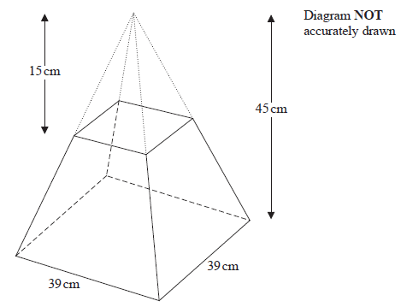
The height of the small pyramid is 15 cm.
The height of the large pyramid is 45 cm.
The square base of the large pyramid has side length 39 cm.
Work out the total surface area of the frustum.
Give your answer correct to the nearest whole number.

....................................................... cm²
(Total for Question 23 is 5 marks)
___________________________________________________________________________
TOTAL FOR PAPER IS 100 MARKS

