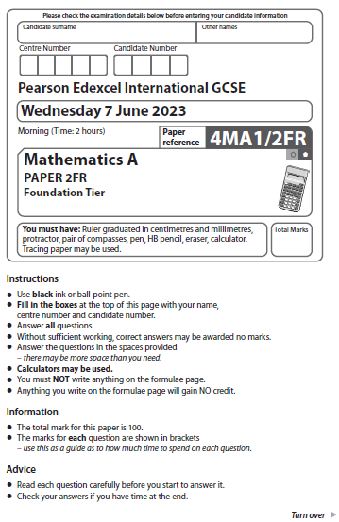
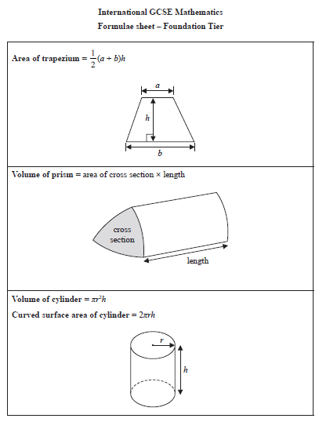

Answer ALL TWENTY FIVE questions.
Write your answers in the spaces provided.
You must write down all the stages in your working.
1
20 | 21 | 23 | 25 | 27 | 29

From the numbers in the box, write down

(a) (i) the even number,

......................................................
(1)
(ii) the square number.

......................................................
(1)
prime | square | cube | factor | product

(b) Complete the following statements by writing a suitable word from the box on each
of the dotted lines.

(i) 343 is the ................................................................................. of 7
(1)
(ii) 9 is a ................................................................................. of 63
(1)
(Total for Question 1 is 4 marks)
__________________________________________________________________________

2 Here is a solid shape.

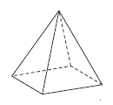

(a) Write down the number of edges of this shape.
......................................................
(1)

(b) On the grid below, draw a shape that is congruent to shape T

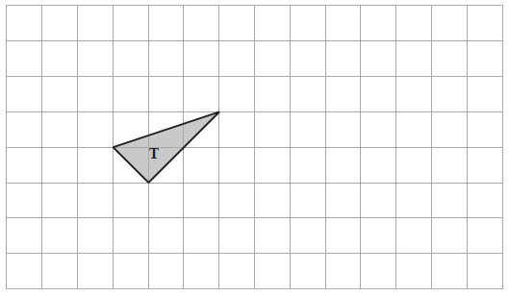
(1)
Here is a parallelogram.
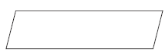
(c) Write down the order of rotational symmetry of the parallelogram.

......................................................
(1)
Here is a scale.
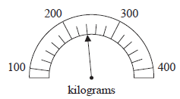

(d) Write down the weight marked by the arrow.

...................................................... kilograms
(1)
(Total for Question 2 is 4 marks)
__________________________________________________________________________

3 The table shows the mean daytime temperature for each of five planets.

Planet | Temperature (°C)
Jupiter | –160
Mars | –30
Mercury | 430
Neptune | –210
Venus | 470

(a) Which of these five planets has the lowest mean daytime temperature?

......................................................
(1)
(b) Work out the difference between the mean daytime temperature for Jupiter and the
mean daytime temperature for Venus.

...................................................... °C
(1)
(Total for Question 3 is 2 marks)
__________________________________________________________________________

4
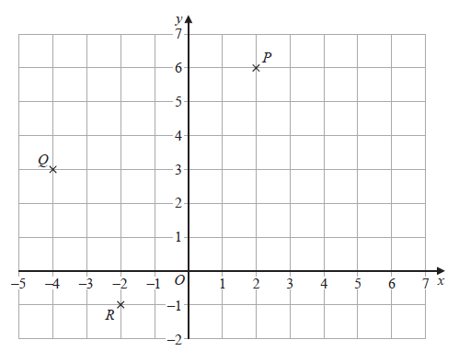

(a) Write down the coordinates of the point
(i) P

(............................ , ............................)
(1)
(ii) Q

(............................ , ............................)
(1)
(b) On the grid above, mark with a cross (×) the point S so that PQRS is a rectangle.
(1)
(Total for Question 4 is 3 marks)
__________________________________________________________________________

5 Here is a list of fractions.

One fraction from the list, when written as a decimal, is not a terminating decimal.
(a) Write down this fraction.

......................................................
(1)
Two fractions from the list are equivalent.
(b) Write down these two fractions.

...................................................... and ......................................................
(1)
(c) Write as a decimal.

......................................................
(1)
(Total for Question 5 is 3 marks)
__________________________________________________________________________

6 Tamzin recorded the colour of each of the cars she saw one afternoon.
She saw only red cars, blue cars, white cars and black cars.
The bar chart gives information about the numbers of red cars, blue cars and white cars
that she saw.
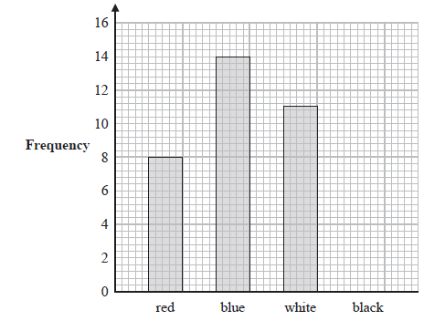
(a) Write down the number of red cars that Tamzin saw.

......................................................
(1)
Tamzin saw 40 cars in total.
(b) Draw a bar on the bar chart to show the number of black cars that Tamzin saw.

(3)
(Total for Question 6 is 4 marks)
__________________________________________________________________________

7 Gerhard is travelling from Zurich to Munich.
The table shows the exchange rate in each city.

Zurich | Munich
1 Swiss franc = 0.90 euros | 1 euro = 1.08 Swiss francs

Gerhard wants to change 1620 Swiss francs to euros.
He would receive more euros if he changes his Swiss francs in Munich than he would
receive if he changes his Swiss francs in Zurich.
How many more?

...................................................... euros
(Total for Question 7 is 4 marks)
__________________________________________________________________________

8 Georgia is a plumber.

She uses this rule to work out the total cost, in euros, of her customers’ bills.

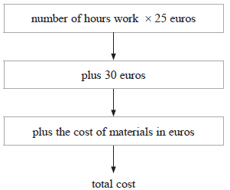

Georgia does some plumbing work for Tallulah.
She works for 3 hours.
The cost of the materials she uses is 42 euros.
(a) Work out the total cost of Tallulah’s bill.

...................................................... euros
(2)
Georgia also does some plumbing work for Sam.
The cost of the materials she uses is 65 euros.
The total cost of Sam’s bill is 220 euros.
(b) Work out the number of hours that Georgia works for Sam.

...................................................... hours
(3)
(Total for Question 8 is 5 marks)
__________________________________________________________________________

9 The diagram shows quadrilateral ABCD

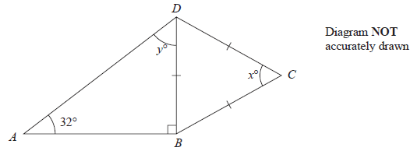
BC = CD = DB
angle DBA = 90° and angle DAB = 32°
(a) Work out the value of x

x = ......................................................
(1)
(b) (i) Work out the value of y

y = ......................................................
(1)
(ii) Give a reason for your answer to (b)(i).

......................................................................................................................................................

......................................................................................................................................................
(1)
(Total for Question 9 is 3 marks)
__________________________________________________________________________

10 Haneul buys 120 packs of cherries.
Each pack of cherries that Haneul buys costs 28 Malaysian ringgits.
Haneul sells of the 120 packs of cherries.
He sells each of these packs for 46 Malaysian ringgits.
The remaining packs are unsold.
Work out Haneul’s total profit.

...................................................... Malaysian ringgits
(Total for Question 10 is 4 marks)
__________________________________________________________________________

11 180 passengers travelled either to Seoul or to Tokyo.
They travelled either business class or economy class.

Of these 180 passengers

51 travelled business class to Seoul
69 travelled economy class to Tokyo
86 in total travelled business class

Use this information to complete the two-way table.

 | Seoul | Tokyo | Total
Business class
Economy class
Total

(Total for Question 11 is 3 marks)
__________________________________________________________________________

12 The scale drawing shows the positions of two boats, A and B
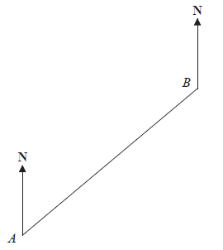
Scale: 1 cm represents 3 km
(a) Work out the actual distance, in kilometres, between A and B

...................................................... km
(2)
Boat C is on a bearing of 110° from B
Boat C is 24 km from B
(b) On the scale drawing, mark with a cross (×) the position of boat C

(3)
(Total for Question 12 is 5 marks)
__________________________________________________________________________

13 One week, an online company carried out a total of 175 deals.
49 of these deals were in yen.
Work out the percentage of deals carried out in yen.

......................................................%
(Total for Question 13 is 2 marks)
__________________________________________________________________________

14 One month, Abbad raised money for charity by being sponsored to run and to walk.
His target was to raise 700 dirhams.
During the month, Abbad recorded a total distance of 135 km by running and by walking.
The ratio
number of km he ran : number of km he walked = 2 : 7
Abbad received 8 dirhams for each km he ran and 5 dirhams for each km he walked.
Abbad raised more money than his 700 dirhams target.
How much more?

...................................................... dirhams
(Total for Question 14 is 4 marks)
__________________________________________________________________________

15 Sayeeda asked the members of a swimming club which one of front crawl, breaststroke,
backstroke or butterfly is their favourite stroke.
The pie chart shows some information about their answers.
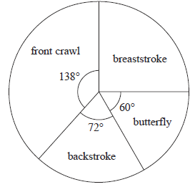
12 members said backstroke.
(a) Work out the number of members who said front crawl.

......................................................
(2)
There are 90 members in a diving club.
The diving club has a beginners group, an intermediate group and an advanced group.
Every member of the diving club is only in one of these groups.
The table shows information about the number of members in each group.
Group | beginners | intermediate | advanced
Frequency | 18 | x | 2x

Kasim chooses at random one of the members of the diving club.
(b) Find the probability that this member is in the intermediate group.

......................................................
(3)
(Total for Question 15 is 5 marks)
__________________________________________________________________________
16 (a) Factorise 6y – 27

.......................................................
(1)
(b) Expand p(p – 2)

.......................................................
(1)
T = 5g + 4r

(c) Work out the value of r when T = 46 and g = 17

r = .......................................................
(3)
P = m² – 4c
(a) Work out the value of P when m = –5 and c = 3

P = ......................................................
(2)
(b) Expand and simplify (x + 5)(x – 7)

......................................................
(2)
(Total for Question 16 is 9 marks)
__________________________________________________________________________

17 Sandeep wants to buy some packets of pens and some boxes of pencils for his
stationery shop.
Each packet of pens contains 9 pens.
Each box of pencils contains 12 pencils.
Each packet of pens costs £7.60
Each box of pencils costs £4.80
Sandeep can only buy full packets of pens and full boxes of pencils.
He wants to buy exactly the same number of pens as pencils.
Work out the minimum amount Sandeep needs to pay.

£......................................................
(Total for Question 17 is 4 marks)
__________________________________________________________________________

18 Anjali travels on the Eurostar train from Paris to Amsterdam.
The distance the train travels between Paris and Amsterdam is 515 km.
The time taken by the train to travel between Paris and Amsterdam is
3 hours 18 minutes.
Work out the average speed of the train.
Give your answer in km/h correct to the nearest whole number.

...................................................... km/h
(Total for Question 18 is 3 marks)
__________________________________________________________________________

19 Here are the first four terms of an arithmetic sequence.

38 31 24 17

Find an expression, in terms of n, for the nth term of the sequence.

.......................................................
(Total for Question 19 is 2 marks)
__________________________________________________________________________

20 A field is in the shape of a trapezium.
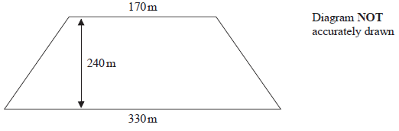
The field is sold for a price of $49 650
Given that 1 hectare = 10 000 m²
work out the average price of the field per hectare.

$......................................................
(Total for Question 20 is 4 marks)
__________________________________________________________________________

21 In his previous job, Pierre was paid 400 euros in total for working a 5-day week.
In his new job, Pierre is paid 14 euros per hour.
In his new job, Pierre works for 7 hours each day for a 5-day week.
(a) Work out the percentage increase in the amount that Pierre is paid for a 5-day week.

......................................................%
(4)
Marie changes her job.
Her salary decreases by 6%
Her new salary is 23 030 euros.
(b) Work out Marie’s salary before she changes her job.

...................................................... euros
(3)
(Total for Question 21 is 7 marks)
__________________________________________________________________________

22 (a) Simplify (4^{–2})⁰

......................................................
(1)
3^{–14} × 3⁸ = 3^{m}
(b) Find the value of m

m = ......................................................
(1)
(Total for Question 22 is 2 marks)
__________________________________________________________________________

23 (a) Solve 9 – 4x > 17

......................................................
(2)
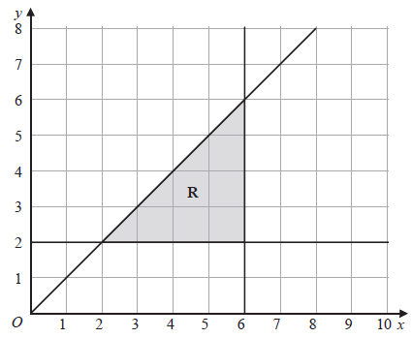

(b) Write down the three inequalities that represent the shaded region R

......................................................

......................................................

......................................................
(3)
(Total for Question 23 is 5 marks)
__________________________________________________________________________

24 The diagram shows a rectangular sheet of metal ABCD

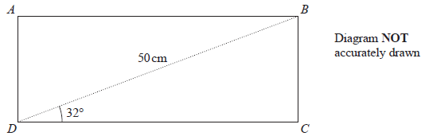

BD = 50 cm and angle BDC = 32°
Nasser joins side AD to side BC to form a cylinder.
BC is the height of the cylinder.
DC is the circumference of the cross section of the cylinder.
Work out the volume, in cm³, of the cylinder.
Give your answer correct to 3 significant figures.

...................................................... cm³
(Total for Question 24 is 6 marks)
__________________________________________________________________________

25 Gemara works as a taxi driver.
Last week, he recorded the following information about the distances he drove.
For the 5 days from Monday to Friday, the mean number of kilometres he drove
was 104
For the 7 days from Monday to Sunday, the mean number of kilometres he drove
was 127
On Saturday, Gemara drove 132 kilometres.
Work out the number of kilometres he drove on Sunday.

...................................................... kilometres
(Total for Question 25 is 3 marks)
__________________________________________________________________________
TOTAL FOR PAPER IS 100 MARKS

