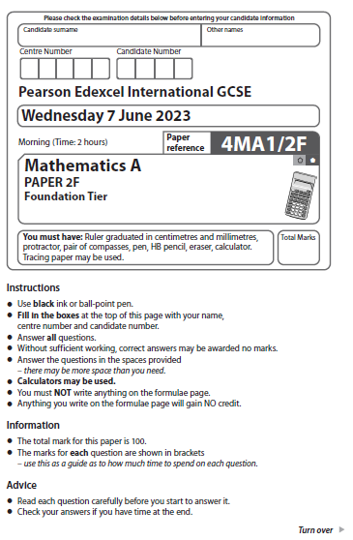
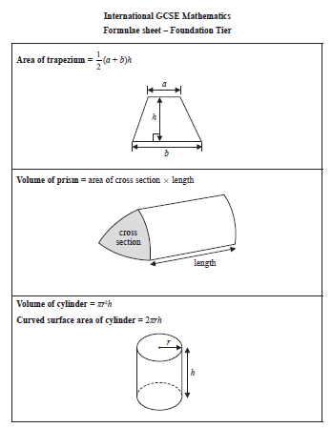

Answer ALL TWENTY EIGHT questions.
Write your answers in the spaces provided.
You must write down all the stages in your working.

1 (a) Write in figures the number seven thousand and fifty four.

..................................................................................
(1)
(b) Write the number 78 263 correct to the nearest 100

..................................................................................
(1)
(c) Write down the value of the 7 in the number 673 000

..................................................................................
(1)
(d) Write a number in the box to make the calculation correct.
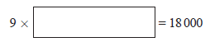
(1)
(e) Write a number in the box to make the calculation correct.
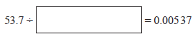
(1)
(Total for Question 1 is 5 marks)
___________________________________________________________________________

2 Here is a list of numbers.

9 | 11 | 13 | 15 | 21 | 60

From the numbers in the list, write down
(a) the even number

.......................................................
(1)
(b) the square number

.......................................................
(1)
(c) the multiple of 7

.......................................................
(1)
(d) the factor of 30

.......................................................
(1)
(Total for Question 2 is 4 marks)
___________________________________________________________________________

3 Peter owns boarding kennels for dogs.

The pictogram shows information about the number of dogs that were at the kennels
each day from Monday to Thursday last week.

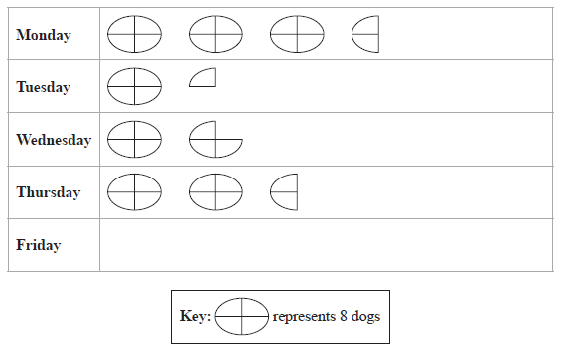
(a) How many dogs were at the kennels on Monday?

.......................................................
(1)
18 dogs were at the kennels on Friday.
(b) Show this information on the pictogram.
(1)
Peter gave each dog 2 biscuits each day.
(c) Work out the total number of biscuits that Peter gave the dogs during the five days
from Monday to Friday last week.

.......................................................
(2)
(Total for Question 3 is 4 marks)
___________________________________________________________________________

4 Here is a sequence of patterns made from sticks.
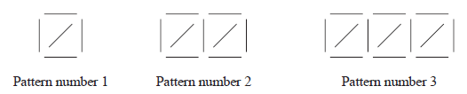
(a) In the space below, draw Pattern number 4

(1)
(b) Complete the table.

Pattern number | 1 | 2 | 3 | 4 | 5
Number of sticks | 5 | 9 | 13
(1)
(c) Work out the number of sticks in Pattern number 10

.......................................................
(1)
Connor says that in Pattern number 25 there are 102 sticks.
(d) Explain why Connor is wrong.

......................................................................................................................................................

......................................................................................................................................................
(1)
(Total for Question 4 is 4 marks)
___________________________________________________________________________

5 The diagram shows three points, A, B and C, marked on a grid.
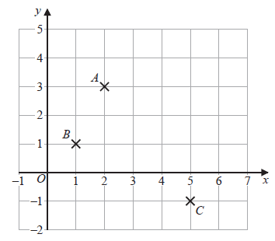

(a) Write down the coordinates of point A

(............................ , ............................)
(1)
(b) On the grid, mark with a cross (×) the point D so that ABCD is a rectangle.
(1)
(c) Find the coordinates of the midpoint of AC

(............................ , ............................)
(2)
(d) On the grid, draw the line with equation y = 4
(1)
(Total for Question 5 is 5 marks)
___________________________________________________________________________

6 (a) Write down the mathematical name of this polygon.

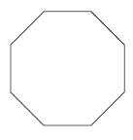

..................................................................................
(1)
(b) Measure the length of the line AB
Give your answer in centimetres.

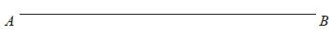

....................................................... cm
(1)
Here are six triangles drawn on a grid of squares.

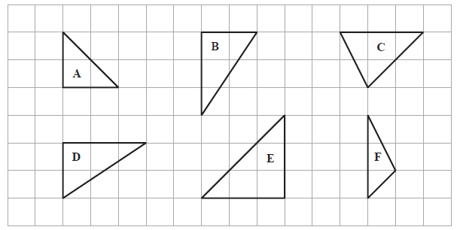

Two of these triangles are congruent.
(c) Write down the letters of these two triangles.
............................ and ............................
(1)
(Total for Question 6 is 3 marks)
__________________________________________________________________________

7 The diagram shows a fair 6-sided spinner.
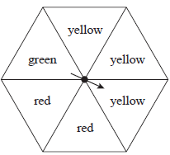
Mario spins the arrow on the spinner once.

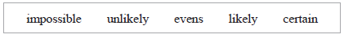
Write down the word from the box that best describes the likelihood that the arrow will
land on
(i) green

.......................................................
(1)
(ii) yellow

.......................................................
(1)
(iii) blue

.......................................................
(1)
(Total for Question 7 is 3 marks)
___________________________________________________________________________

8 A hall has 26 rows of seats.
There are 14 seats in each row.
Annie sells tickets for of the seats in the hall for a concert.
She sells each ticket for 15 euros.
Work out the total amount Annie gets from selling tickets.

....................................................... euros
(Total for Question 8 is 3 marks)
___________________________________________________________________________

9 Here is a sketch of triangle ABC
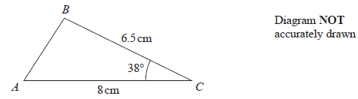
AC = 8 cm BC = 6.5 cm angle ACB = 38°
In the space below, make an accurate drawing of triangle ABC
The line AC has been drawn for you.

(Total for Question 9 is 2 marks)
___________________________________________________________________________

10 Adriana makes some cupcakes.
She sells each cupcake for £2.20
Mike buys 6 of these cupcakes.
He pays with a £20 note.
(a) Work out how much change Mike should receive.

£.......................................................
(2)
Greta sells balloons.
She sells each balloon for £0.85
Stefan has £50 to spend on balloons.
(b) Work out the greatest number of balloons he can buy.

.......................................................
(2)
(Total for Question 10 is 4 marks)
___________________________________________________________________________

11 Trisha asked 90 people to name their favourite type of cheese to put on a pizza.
She is going to draw a pie chart for her results.
55 of the 90 people said that mozzarella was their favourite.
(a) Work out the size of the angle on the pie chart for the sector
representing mozzarella.

.......................................................°
(2)
Haashir asked a different group of people to name their favourite ice cream flavour.
He used his results to draw this pie chart.
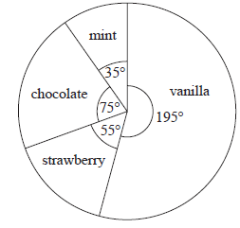
39 of the people Haashir asked said that vanilla was their favourite.
(b) Work out how many of the people Haashir asked said that chocolate was
their favourite.

.......................................................
(2)
(Total for Question 11 is 4 marks)
___________________________________________________________________________

12 A circle has radius 8.5 cm
Work out the circumference of the circle.
Give your answer correct to 3 significant figures.

....................................................... cm
(Total for Question 12 is 2 marks)
___________________________________________________________________________

13 (a) Expand x(3 – x)

.......................................................
(1)
(b) Factorise fully 12a – 18b

.......................................................
(2)
There are 8 slices of cheese in each small pack of cheese.
There are 20 slices of cheese in each large pack of cheese.
Afreen buys h small packs of cheese and j large packs of cheese.
She buys a total of T slices of cheese.
(c) Write down a formula for T in terms of h and j

.......................................................
(3)
(Total for Question 13 is 6 marks)
___________________________________________________________________________

14

1 dollar = 0.85 euros
1 dollar = 6.45 yuan

(a) Change 720 dollars to euros.

....................................................... euros
(1)
(b) Change 2580 yuan to euros.

....................................................... euros
(2)
(Total for Question 14 is 3 marks)
___________________________________________________________________________

15 Finn is asked to find the value of 5 + 3² + 12
Here is his working and his answer.
5 + 3² + 12 = 8² + 12
= 64 + 12
= 76
Finn’s answer is wrong.
(a) Explain what Finn has done wrong in his working.

......................................................................................................................................................

......................................................................................................................................................(1)
(b) Write one pair of brackets in this calculation so that the answer is correct.

2 × 6 – 4² – 14 = 10

(1)
(c) Work out the value of x² + 5y when x = –3 and y = 2

.......................................................
(2)
(Total for Question 15 is 4 marks)
___________________________________________________________________________

16 The scale drawing shows the positions of two airports P and Q
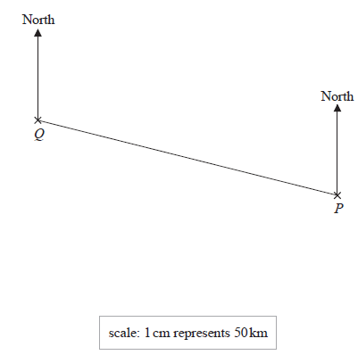
(a) Find, by measuring, the bearing of P from Q

......................................................°
(1)
A small plane flies directly from P to Q
The plane takes 2 hours to fly from P to Q
(b) Work out the average speed of the plane.
Give your answer in km/h

....................................................... km/h
(3)
(Total for Question 16 is 4 marks)
___________________________________________________________________________

17 Show that

(Total for Question 17 is 3 marks)
__________________________________________________________________________

18 A biased spinner can land on green or on yellow or on brown or on pink.
The table gives the probabilities that, when the spinner is spun, it will land on green or
on yellow or on brown.
Colour | green | yellow | brown | pink
Probability | 0.32 | 0.13 | 0.28
Timucin spins the spinner 200 times.
Work out an estimate for the number of times the spinner lands on pink.

.......................................................
(Total for Question 19 is 3 marks)
__________________________________________________________________________

19 ABCD is a trapezium.
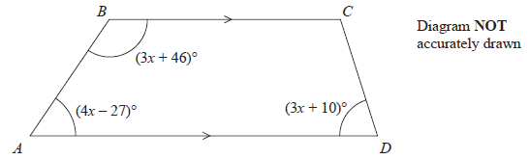
BC is parallel to AD
Find the size of the largest angle inside the trapezium.

....................................................... °
(Total for Question 19 is 4 marks)
__________________________________________________________________________

20 (a) Complete the table of values for y = x² – x – 4

x | –3 | –2 | –1 | 0 | 1 | 2 | 3
y |  | 2 |  |  | –4
(2)
(b) On the grid below, draw the graph of y = x² – x – 4 for values of x from –3 to 3
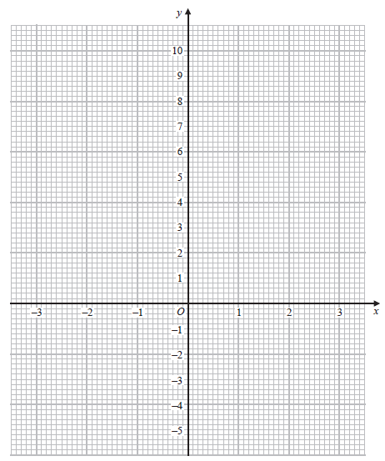
(2)
(Total for Question 20 is 4 marks)
__________________________________________________________________________

21 Nancy has some coins with a total value of 85 pence.
She has only 2 pence coins and 5 pence coins.
The ratio
number of 2 pence coins : number of 5 pence coins = 1 : 3

Nancy has more 5 pence coins than 2 pence coins.
How many more?

.......................................................
(Total for Question 21 is 4 marks)
__________________________________________________________________________

22 (a) Write 76 000 000 in standard form.

.......................................................
(1)
(b) Write 5.4 × 10^{–4} as an ordinary number.

.......................................................
(1)
(Total for Question 22 is 2 marks)
__________________________________________________________________________

23
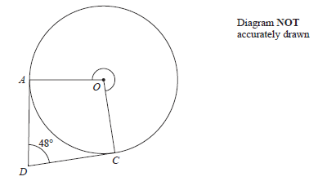
A and C are points on a circle, centre O
DA is the tangent to the circle at A and DC is the tangent to the circle at C
Angle ADC = 48°
Work out the size of reflex angle AOC

....................................................... °
(Total for Question 23 is 3 marks)
__________________________________________________________________________

24 Charlotte buys a painting for $680
The value of the painting increases by 4% each year.
Work out the value of the painting at the end of 3 years.
Give your answer correct to the nearest $

$.......................................................
(Total for Question 24 is 3 marks)
__________________________________________________________________________

25 Change a speed of 27 kilometres per hour to a speed in metres per second.

....................................................... m/s
(Total for Question 25 is 3 marks)
__________________________________________________________________________

26 Team A and Team B take part in a quiz league.
After 11 rounds, Team A has a mean score per round of 17
After 9 rounds, Team B has a mean score per round of 18
Both teams take part in a further round.
After this round, both teams have a mean score per round of 18.5
In the further round, Team A scored more points than Team B.
How many more?

.......................................................
(Total for Question 26 is 4 marks)
__________________________________________________________________________

27 Here is a 9-sided regular polygon ABCDEFGHJ, with centre O

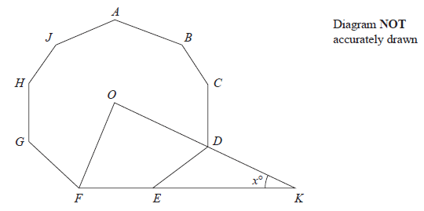
ODK and FEK are straight lines.
Work out the value of x

x = .......................................................
(Total for Question 27 is 3 marks)
__________________________________________________________________________

28 The diagram shows right-angled triangle ABD
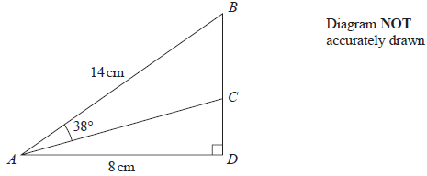
AB = 14 cm AD = 8 cm
C is the point on BD such that angle BAC = 38°
Work out the length of CD
Give your answer correct to 3 significant figures.

....................................................... cm
(Total for Question 28 is 4 marks)
__________________________________________________________________________
TOTAL FOR PAPER IS 100 MARKS

