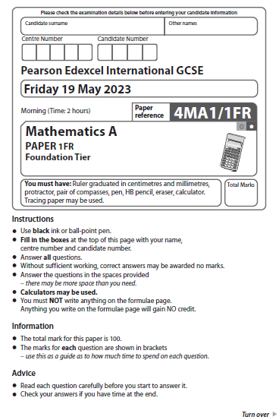
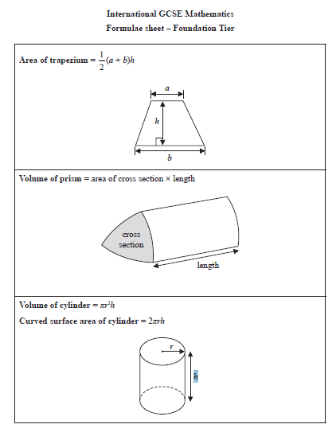

Answer ALL TWENTY EIGHT questions.
Write your answers in the spaces provided.
You must write down all the stages in your working.

1 The table shows the number of steps Polly walked on each of five days.

Day | Number of steps
Monday | 8 927
Tuesday | 11 362
Wednesday | 9 653
Thursday | 10 980
Friday | 6 411

(a) On which of these days did Polly walk the greatest number of steps?

............................................................................................................
(1)
(b) Write the number 9653 in words.
..
....................................................................................................................................................
(1)
(c) Write the number 8927 correct to the nearest ten.

......................................................
(1)
(d) Write down the value of the 9 in the number 10 980

......................................................
(1)
(e) Work out the sum of the number of steps Polly walked on Thursday and on Friday.

......................................................
(1)
(Total for Question 1 is 5 marks)
___________________________________________________________________________
2 The diagram shows a fair spinner with six sections.
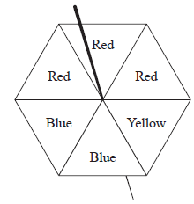
Three sections are red, two sections are blue and one section is yellow.

impossible | unlikely | evens | likely | certain

The spinner is spun once.
(a) Write down a word from the box to describe the likelihood that the spinner lands
on yellow.

..................................................................................
(1)
(b) On the probability scale, mark with a cross (×) the probability that the spinner lands
on green.
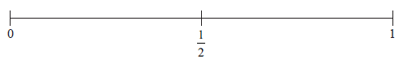
(1)
Here are 8 number cards.
3 of the number cards are blank.



Hugo is going to take at random one of these cards.
(c) Write a number on each of the 3 blank cards so that the probability that Hugo picks
a card with an odd number is
(1)
(Total for Question 2 is 3 marks)
___________________________________________________________________________
3 The diagram shows a 5-sided polygon, ABCDE
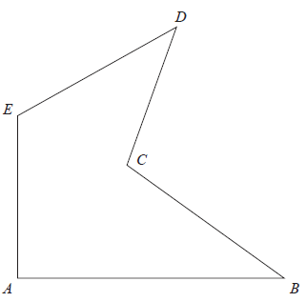

(a) Write down the mathematical name for a 5-sided polygon.

..................................................................................
(1)
(b) Measure the length of the line AB
Give your answer in centimetres.

...................................................... cm
(1)
(c) On the diagram, mark an obtuse angle with the letter T
(1)
(Total for Question 3 is 3 marks)
___________________________________________________________________________

4 Here is a shape made of squares.

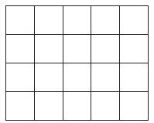
(a) Shade of the shape.
(1)
(b) Write 0.7 as a percentage.

...................................................... %
(1)
(c) Write these decimals in order of size.
Start with the smallest decimal.
0.49 | 0.459 | 0.4 | 0.049 | 0.14

......................................................................................................................................................
(1)
(Total for Question 4 is 3 marks)
___________________________________________________________________________

5 Here are the first four terms of a number sequence.

2 | 6 | 10 | 14

Elsie correctly works out that the next term in the sequence is 18
(a) Explain how she was able to work this out.

......................................................................................................................................................
(1)
(b) Explain why 217 cannot be a number in the sequence.

......................................................................................................................................................

......................................................................................................................................................
(1)
(Total for Question 5 is 2 marks)
___________________________________________________________________________

6 Niran is organising a baking competition and needs to buy 9.25 kilograms of flour.
Flour is sold in bags that each contain 750 grams of flour.
Each of these bags costs 58 Baht.
Niran can only buy whole bags of flour.
Niran buys the least number of bags of flour that he needs.
Work out the cost of the flour that he buys.

...................................................... Baht
(Total for Question 6 is 4 marks)
___________________________________________________________________________

7 (a) Simplify 6a × 2c

......................................................
(1)
(b) Simplify 4d + 3e + d – 5e

......................................................
(2)
(c) Solve 4x – 7 = 23

x = ......................................................
(2)
(Total for Question 7 is 5 marks)
___________________________________________________________________________

8 (a) Write down the prime number that lies between 90 and 100

......................................................
(1)
(b) Find the cube root of 79 507

......................................................
(1)
(c) Work out the value of 4² × 5³

......................................................
(2)
(Total for Question 8 is 4 marks)
___________________________________________________________________________
9 The pictogram gives some information about the number of cars sold by each of the
four employees of Best Cars in April.
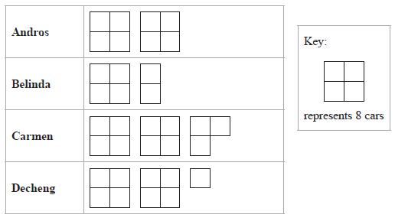
In March, Best Cars sold 60 cars in total.
Its target for April was to sell 15% more cars in total than it sold in March.
Show that Best Cars did not meet its target.
Show your working clearly.

(Total for Question 9 is 4 marks)
___________________________________________________________________________

10 The diagram shows quadrilateral ABCD
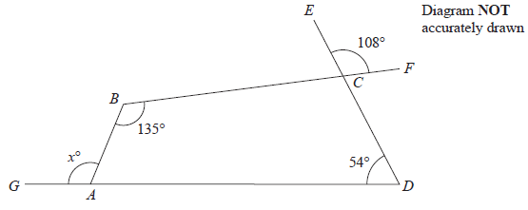

ECD, BCF and GAD are straight lines.
Work out the value of x
Give a reason for each stage of your working.

x = ......................................................
(Total for Question 10 is 5 marks)
___________________________________________________________________________

11 The table shows how many cousins each of 30 students in Class A has.

Number of cousins | Frequency
0 | 3
1 | 7
2 | 6
3 | 11
4 | 1
5 | 2

(a) Work out the range of the number of cousins.

......................................................
(1)
(b) Write down the mode of the number of cousins.

......................................................
(1)
(c) Work out the mean of the number of cousins.

......................................................
(3)
(Total for Question 11 is 5 marks)
___________________________________________________________________________

12 On the grid, draw the graph of y = 4 – 2x for values of x from –1 to 4

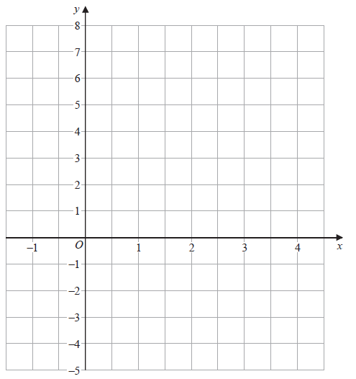

(Total for Question 12 is 3 marks)
___________________________________________________________________________

13 The diagram shows the plan of a garden.

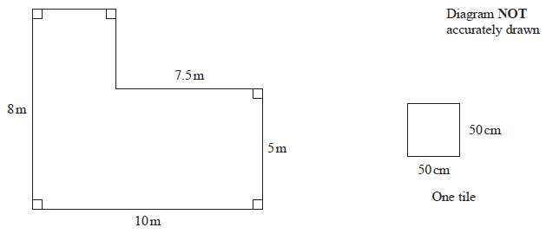Martyn covers the garden with square tiles of side length 50 cm.
There are no gaps between the tiles.
It takes 4 minutes to lay each tile.
Work out how long it takes Martyn to cover the whole garden with tiles.
Give your answer in hours and minutes.

............................ hours ............................ minutes
(Total for Question 13 is 5 marks)
___________________________________________________________________________

14 A small bag of grain contains 2 kg of grain.
A large sack of grain contains 7 kg of grain.
Makenna buys r small bags of grain and h large sacks of grain.
The total amount of grain Makenna buys is F kg.
Write down a formula for F in terms of r and h

............................................................................................................
(Total for Question 14 is 3 marks)
___________________________________________________________________________

15 Show that

(Total for Question 15 is 2 marks)
___________________________________________________________________________
16 Roland, Seiso and Tim share the total cost of buying a plot of land.
Roland and Seiso share some of the cost in the ratio 2 : 5
Roland’s share of the cost is $1700
Tim’s share of the cost is $2150 more than Roland’s share.
Work out the total cost of buying the plot of land.

$......................................................
(Total for Question 16 is 4 marks)
___________________________________________________________________________

17 Write 2250 as a product of powers of its prime factors.
Show your working clearly.

............................................................................................................
(Total for Question 17 is 3 marks)
___________________________________________________________________________

18 Here is a Venn diagram.

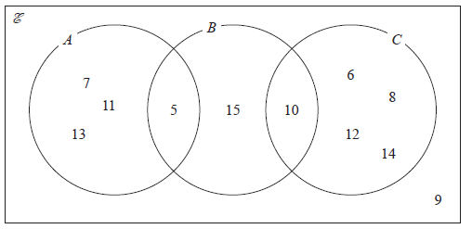

(a) Write down the numbers that are in the set

(i) A

............................................................................................................
(1)
(ii) B ∪ C
............................................................................................................
(1)
Dominic writes down 9 ∉ C
(b) Explain why Dominic is correct.

......................................................................................................................................................

......................................................................................................................................................
(1)
(Total for Question 18 is 3 marks)
___________________________________________________________________________

19 ABCD and EFGH are similar quadrilaterals.
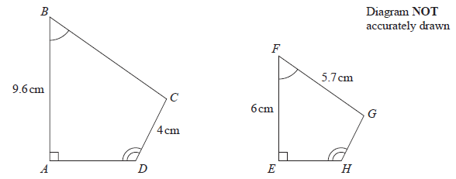

(a) Work out the length of GH

...................................................... cm
(2)
(b) Work out the length of BC

...................................................... cm
(2)
(Total for Question 19 is 4 marks)
___________________________________________________________________________

20 The diagram shows a shape made up of three semicircles, enclosing a
right‑angled triangle.

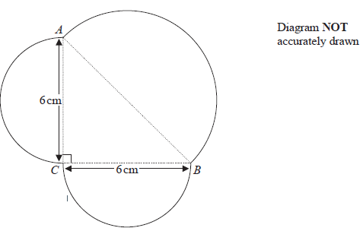

AB, BC and CA are each the diameter of a semicircle.
BC = CA = 6 cm.
Work out the perimeter of the shape.
Give your answer correct to one decimal place.

...................................................... cm
(Total for Question 20 is 5 marks)
___________________________________________________________________________

21 Each time Evie plays a game against her computer, she will win or lose.
For each game, the probability that Evie will win is 0.74
Evie is going to play 300 games against her computer.
Work out an estimate for the number of games that Evie will lose.

......................................................
(Total for Question 21 is 2 marks)
___________________________________________________________________________

22 (a) Simplify m¹⁰ ÷ m³

......................................................
(1)
k^{n} × k⁴ = k¹²
(b) Write down the value of n

n = ......................................................
(1)
(c) Simplify (3x⁶ y⁸)²

..................................................................................
(2)
(Total for Question 22 is 4 marks)
___________________________________________________________________________

23 (a) Expand 4x(x – 5)

..................................................................................
(1)
(b) Factorise y² – 9y + 20

..................................................................................
(2)
(Total for Question 23 is 3 marks)
___________________________________________________________________________

24 (a) Write 5.6 × 10^{–3} as an ordinary number.

......................................................
(1)
(b) Work out
Give your answer in standard form.

......................................................
(2)
(Total for Question 24 is 3 marks)
___________________________________________________________________________

25 Kazi buys a car for 700 000 taka.
The value of the car depreciates by 12% each year.
Work out the value of the car at the end of 3 years.
Give your answer correct to the nearest taka.

...................................................... taka
(Total for Question 25 is 3 marks)
___________________________________________________________________________

26
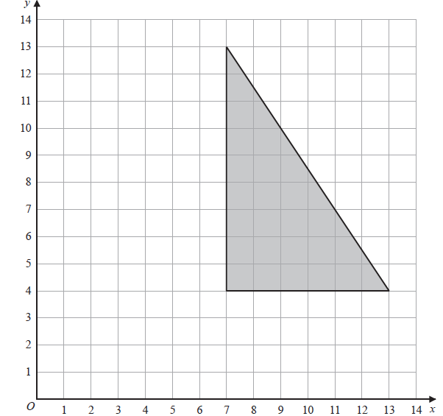

On the grid, enlarge the shaded shape with scale factor and centre (1, 7)

(Total for Question 26 is 2 marks)
___________________________________________________________________________

27 The diagram shows a block of iron in the shape of a cuboid.
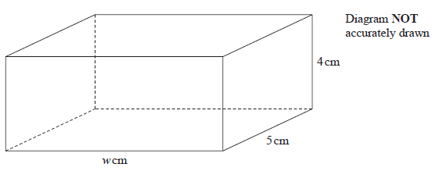

The block has length w cm, width 5 cm and height 4 cm
The density of iron is 7.8 g / cm³
The mass of the block is 1950 g
Work out the value of w

w = ......................................................
(Total for Question 27 is 3 marks)
___________________________________________________________________________

28 Moeen has a biased 6-sided dice.
The table gives information about the probability that, when the dice is thrown, it will
land on each number.

Number | 1 | 2 | 3 | 4 | 5 | 6
Probability | x | 0.15 | 0.5 | y | 0.13 | 0.03

(a) Show that x + y = 0.19

(2)
Given that 3x – y = 0.09
and x + y = 0.19
(b) work out the value of x and the value of y
Show clear algebraic working.

x = ......................................................

y = ......................................................
(3)
(Total for Question 28 is 5 marks)
___________________________________________________________________________
TOTAL FOR PAPER IS 100 MARKS

