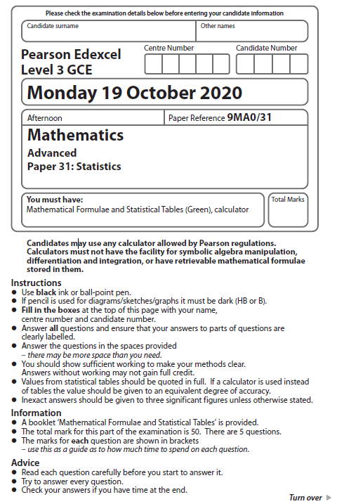

1 The Venn diagram shows the probabilities associated with four events, A, B, C and D

(a) Write down any pair of mutually exclusive events from A, B, C and D
(1)

Given that P(B) = 0.4

(b) find the value of p
(1)

Given also that A and B are independent

(c) find the value of q
(2)

Given further that P ( Bʹ | C ) = 0.64

(d) find

(i) the value of r

(ii) the value of s
(4)
(Total for Question 1 is 8 marks)
___________________________________________________________________________

2 A random sample of 15 days is taken from the large data set for Perth in June and July 1987.

The scatter diagram in Figure 1 displays the values of two of the variables for these 15 days.

(a) Describe the correlation.
(1)

The variable on the x-axis is Daily Mean Temperature measured in °C.

(b) Using your knowledge of the large data set,

(i) suggest which variable is on the y-axis,

(ii) state the units that are used in the large data set for this variable.
(2)

Stav believes that there is a correlation between Daily Total Sunshine and
Daily Maximum Relative Humidity at Heathrow.

He calculates the product moment correlation coefficient between these two variables
for a random sample of 30 days and obtains r = −0.377

(c) Carry out a suitable test to investigate Stav’s belief at a 5% level of significance.
State clearly

- your hypotheses
- your critical value
(3)

On a random day at Heathrow the Daily Maximum Relative Humidity was 97%

(d) Comment on the number of hours of sunshine you would expect on that day,
giving a reason for your answer.
(1)
(Total for Question 2 is 7 marks)
___________________________________________________________________________

3 Each member of a group of 27 people was timed when completing a puzzle.

The time taken, x minutes, for each member of the group was recorded.

These times are summarised in the following box and whisker plot.

(a) Find the range of the times.
(1)
(b) Find the interquartile range of the times.
(1)

For these 27 people

(c) calculate the mean time taken to complete the puzzle,
(1)
(d) calculate the standard deviation of the times taken to complete the puzzle.
(2)

Taruni defines an outlier as a value more than 3 standard deviations above the mean.

(e) State how many outliers Taruni would say there are in these data, giving a reason for
your answer.
(1)

Adam and Beth also completed the puzzle in a minutes and b minutes respectively,
where a > b.

When their times are included with the data of the other 27 people

- the median time increases
- the mean time does not change

(f) Suggest a possible value for a and a possible value for b, explaining how your
values satisfy the above conditions.
(3)
(g) Without carrying out any further calculations, explain why the standard deviation of
all 29 times will be lower than your answer to part (d).
(1)
(Total for Question 3 is 10 marks)
___________________________________________________________________________

4 The discrete random variable D has the following probability distribution

where k is a constant.

(a) Show that the value of k is
(2)
The random variables D1 and D2 are independent and each have the same distribution as D.

(b) Find P (D₁ + D₂ = 80)
Give your answer to 3 significant figures.
(3)

A single observation of D is made.

The value obtained, d, is the common difference of an arithmetic sequence.

The first 4 terms of this arithmetic sequence are the angles, measured in degrees,
of quadrilateral Q

(c) Find the exact probability that the smallest angle of Q is more than 50°
(5)
(Total for Question 4 is 10 marks)
___________________________________________________________________________
5 A health centre claims that the time a doctor spends with a patient can be modelled by a
normal distribution with a mean of 10 minutes and a standard deviation of 4 minutes.

(a) Using this model, find the probability that the time spent with a randomly selected
patient is more than 15 minutes.
(1)

Some patients complain that the mean time the doctor spends with a patient is more than
10 minutes.

The receptionist takes a random sample of 20 patients and finds that the mean time the
doctor spends with a patient is 11.5 minutes.

(b) Stating your hypotheses clearly and using a 5% significance level, test whether or
not there is evidence to support the patients’ complaint.
(4)

The health centre also claims that the time a dentist spends with a patient during
a routine appointment, T minutes, can be modelled by the normal distribution
where T ~ N(5, 3.5²)

(c) Using this model,

(i) find the probability that a routine appointment with the dentist takes less than 2
minutes
(1)
(ii) find P (T < 2 | T > 0)
(3)
(iii) hence explain why this normal distribution may not be a good model for T.
(1)

The dentist believes that she cannot complete a routine appointment in less than 2 minutes.

She suggests that the health centre should use a refined model only including values
of T > 2

(d) Find the median time for a routine appointment using this new model, giving your
answer correct to one decimal place.
(5)
(Total for Question 5 is 15 marks)
__________________________________________________________________________TOTAL FOR PAPER IS 50 MARKS

