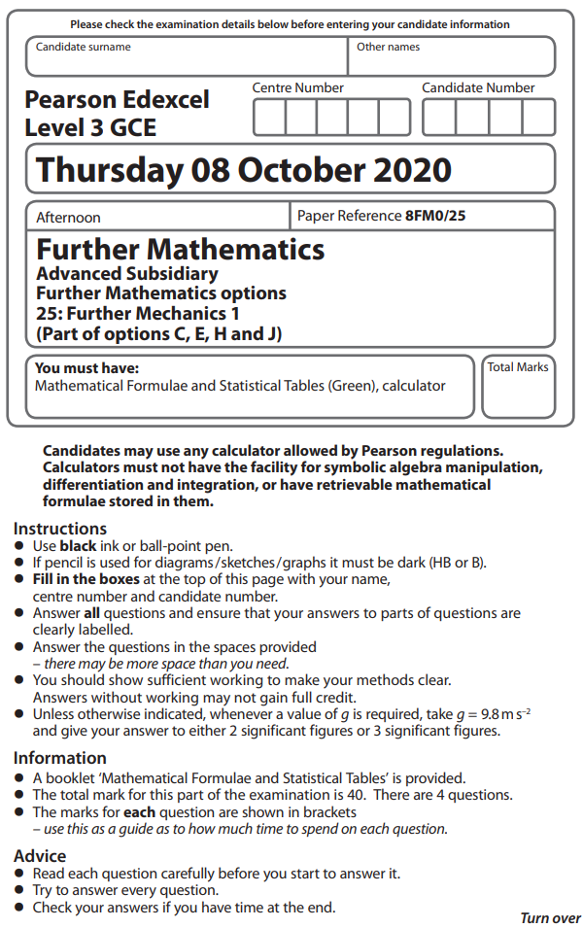
1 Two particles P and Q have masses m and 4m respectively. The particles are at rest on a
smooth horizontal plane. Particle P is given a horizontal impulse, of magnitude I, in the
direction PQ. Particle P then collides directly with Q. Immediately after this collision,
P is at rest and Q has speed w. The coefficient of restitution between the particles is e.
(a) Find I in terms of m and w.
(2)
(b) Show that e =
(1)
(c) Find, in terms of m and w, the total kinetic energy lost in the collision between P and Q.
(2)
(Total for Question 1 is 5 marks)
___________________________________________________________________________

2 A car of mass 1000 kg moves along a straight horizontal road.
In all circumstances, when the speed of the car is v m s^{–1}, the resistance to the motion of
the car is modelled as a force of magnitude cv² N, where c is a constant.
The maximum power that can be developed by the engine of the car is 50 kW.
At the instant when the speed of the car is 72 km h^{–1} and the engine is working at its
maximum power, the acceleration of the car is 2.25 m s^{–2}
(a) Convert 72 km h^{–1} into m s^{–1}
(1)
(b) Find the acceleration of the car at the instant when the speed of the car is 144 km h^{–1}
and the engine is working at its maximum power.
(7)

The maximum speed of the car when the engine is working at its maximum power
is V km h^{–1}.
(c) Find, to the nearest whole number, the value of V.
(4)
(Total for Question 2 is 12 marks)
___________________________________________________________________________

3 Three particles A, B and C are at rest on a smooth horizontal plane. The particles lie along
a straight line with B between A and C.
Particle B has mass 4m and particle C has mass km, where k is a positive constant.
Particle B is projected with speed u along the plane towards C and they collide directly.
The coefficient of restitution between B and C is
(a) Find the range of values of k for which there would be no further collisions.
(8)

The magnitude of the impulse on B in the collision between B and C is 3mu
(b) Find the value of k.
(4)
(Total for Question 3 is 12 marks)
___________________________________________________________________________

4 A small ball, of mass m, is thrown vertically upwards with speed from a point O
on a smooth horizontal floor. The ball moves towards a smooth horizontal ceiling that is
a vertical distance H above O. The coefficient of restitution between the ball and the
ceiling is
In a model of the motion of the ball, it is assumed that the ball, as it moves up or down, is
subject to air resistance of constant magnitude mg.
Using this model,
(a) use the work-energy principle to find, in terms of g and H, the speed of the ball
immediately before it strikes the ceiling,
(5)
(b) find, in terms of g and H, the speed of the ball immediately before it strikes the floor at
O for the first time.
(5)

In a simplified model of the motion of the ball, it is assumed that the ball, as it moves up
or down, is subject to no air resistance.
Using this simplified model,
(c) explain, without any detailed calculation, why the speed of the ball, immediately before
it strikes the floor at O for the first time, would still be less than
(1)
(Total for Question 4 is 11 marks)
___________________________________________________________________________

TOTAL FOR FURTHER MECHANICS 1 IS 40 MARKS

