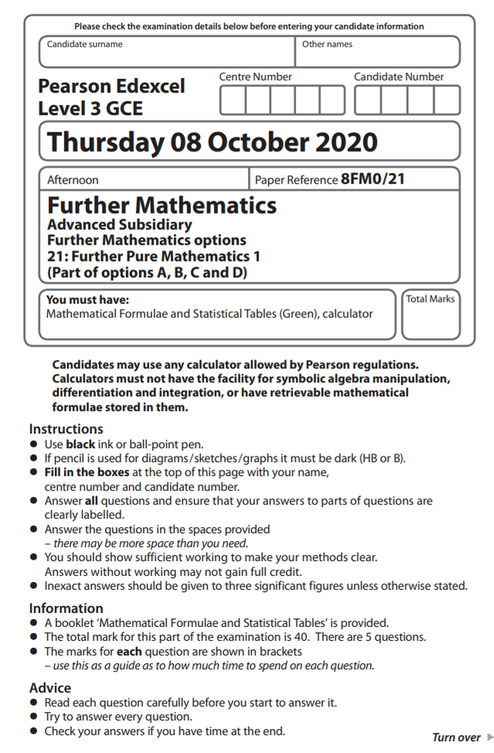
1 The variables x and y satisfy the differential equation
= 2y² – x – 1
where = 3 and y = 0 at x = 0
Use the approximations
and
with h = 0.1 to find an estimate for the value of y at x = 0.2
(7)
(Total for Question 1 is 7 marks)
___________________________________________________________________________

2 Use algebra to determine the values of x for which
(5)
(Total for Question 2 is 5 marks)
___________________________________________________________________________

3 (i) Use the substitution t = tan to prove that
cot x + tan = cosec x x ≠ nπ, n ∈ ℤ
(2)
(ii)
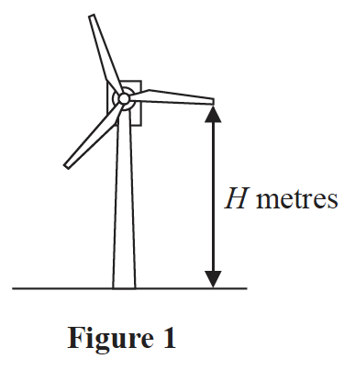
An engineer models the vertical height above the ground of the tip of one blade of a
wind turbine, shown in Figure 1. The ground is assumed to be horizontal.
The vertical height of the tip of the blade above the ground, H metres, at time x seconds
after the wind turbine has reached its constant operating speed, is modelled by the equation
H = 90 – 30cos(120x)° – 40sin(120x)° (I)
(a) Show that H = 60 when x = 0
(1)

Using the substitution t = tan(60x)°
(b) show that equation (I) can be rewritten as
H =
(3)
(c) Hence find, according to the model, the value of x when the tip of the blade is 100 m
above the ground for the first time after the wind turbine has reached its constant
operating speed.
(5)
(Total for Question 3 is 11 marks)
___________________________________________________________________________

4
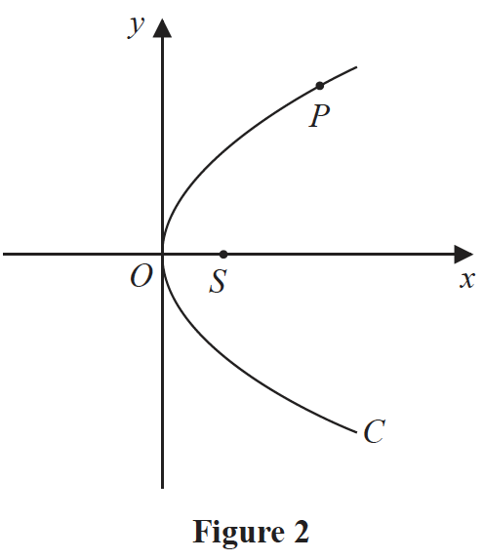
Figure 2 shows a sketch of the parabola C with equation y² = 4ax, where a is a positive
constant. The point S is the focus of C and the point P(ap², 2ap) lies on C where p > 0
(a) Write down the coordinates of S.
(1)
(b) Write down the length of SP in terms of a and p.
(1)

The point Q(aq², 2aq), where p ≠ q, also lies on C.
The point M is the midpoint of PQ.
Given that pq = –1
(c) prove that, as P varies, the locus of M has equation
y² = 2a(x – a)
(5)
(Total for Question 4 is 7 marks)
___________________________________________________________________________

5
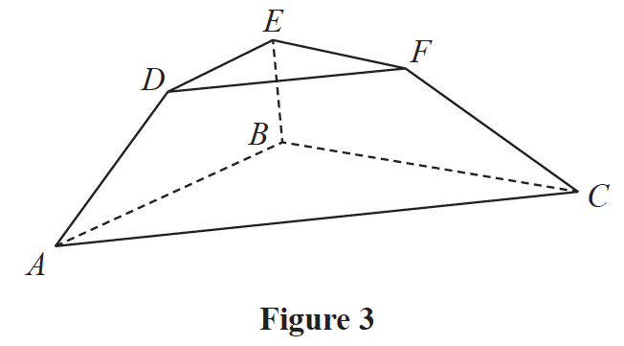
Figure 3 shows a solid display stand with parallel triangular faces ABC and DEF.
Triangle DEF is similar to triangle ABC.
With respect to a fixed origin O,
the points A, B and C have coordinates (3, –3, 1), (–5, 3, 3) and (1, 7, 5) respectively and
the points D, E and F have coordinates (2, –1, 8), (–2, 2, 9) and (1, 4, 10) respectively.
The units are in centimetres.
(a) Show that the area of the triangular face DEF is cm²
(3)
(b) Find, in cm³, the exact volume of the display stand.
(7)
(Total for Question 5 is 10 marks)
___________________________________________________________________________

TOTAL FOR FURTHER PURE MATHEMATICS 1 IS 40 MARKS

