**Using the second derivative**

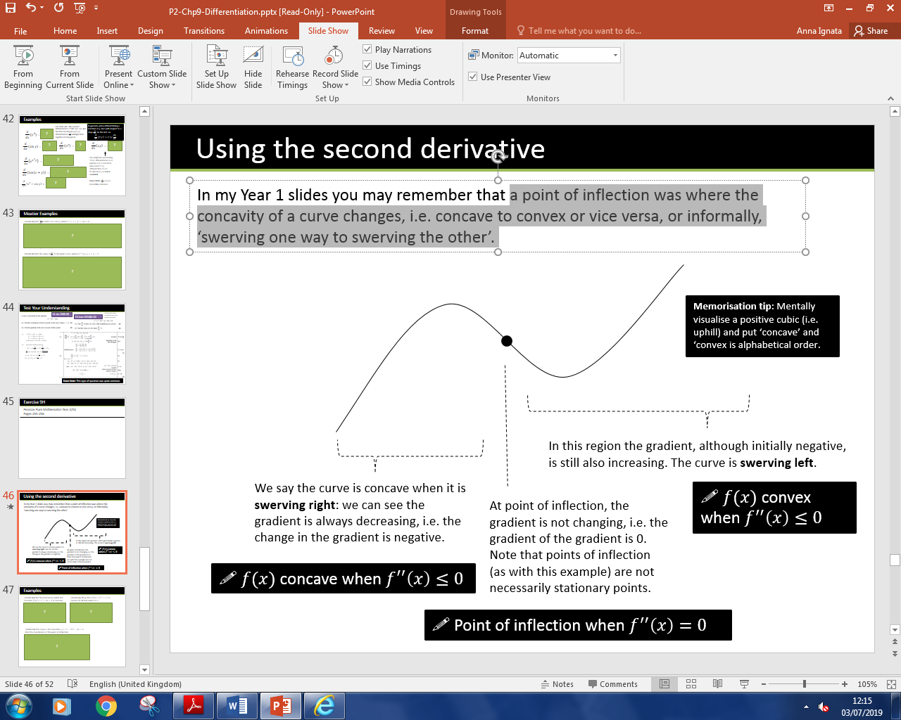Reminder: a point of inflection is where the concavity of a curve changes, i.e. concave to convex or vice versa, or informally, ‘swerving one way to swerving the other’.

**Examples**

1. **Find the interval on which the function $f\left(x\right)=x^{3}+4x+3$ is concave.**
2. **Show that $f\left(x\right)=e^{2x}+x^{2}$ is convex for all real values of $x$.**
3. **The curve $C$ has equation $y=x^{3}-2x^{2}-4x+5.$ Find the coordinates of the point of inflection.**

Exercise 9I Page 259-261