**Implicit Differentiation**

You’re used to differentiating expressions where $y$ is the subject, e.g. $y=x^{2}+3x$. The relationship between $x$ and $y$ is ‘explicit’ in the sense we can directly calculate $y$ from $x$.

But what about **implicit** relations, e.g:

$$x^{2}+y^{2}=8x or \cos\left(x+y\right)=\sin{y}$$

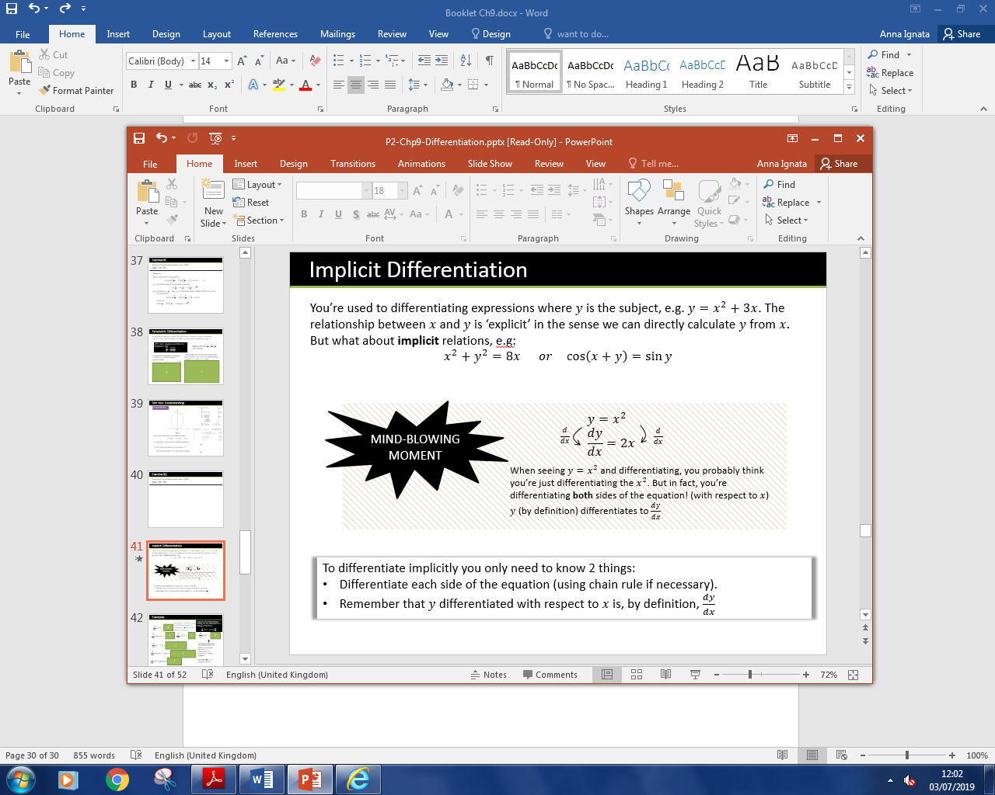

**In general, when differentiating a function of $y$, but with respect to $x$, slap a $\frac{dy}{dx}$ on the end. i.e.**

$$\frac{d}{dx}\left(f\left(y\right)\right)=f^{'}\left(y\right)\frac{dy}{dx}$$

**Examples**

$\frac{d}{dx}\left(y^{2}\right)$

$\frac{d}{dx}\left(\sin{y}\right)$

$\frac{d}{dx}\left(e^{y}\right)$

$\frac{d}{dx}\left(xy\right)$

$\frac{d}{dx}\left(e^{x^{2}y}\right)$

$\frac{d}{dx}\left(\tan\left(x+y\right)\right)$

$\frac{d}{dx}\left(x^{2}+\cos{y}\right)$

**Meatier Examples**

**[Textbook] Find $\frac{dy}{dx}$ in terms of $x$ and $y$ where $x^{3}+x+y^{3}+3y=6$**

**[Textbook] Find the value of $\frac{dy}{dx}$ at the point $(1,1)$, where $e^{2x}\ln{y}=x+y-2$**

**Test Your Understanding**

C4 Jan 2008 Q5

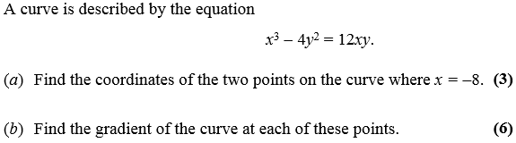

C4 June 2014(R) Q3

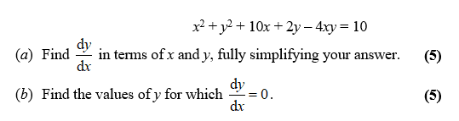

Exercise 9H Page 255-256