**The Product Rule**

**As mentioned previously, the product rule is used, unsurprisingly, when we have a product of two functions.**

**The product rule:**

This is quite easy to remember. Differentiate one of the things but leave the other. Then do the other way round. Then add!

Since addition is commutative, it doesn’t matter which way round we do it.

**If $y=uv$ then $\frac{dy}{dx}=u\frac{dv}{dx}+v\frac{du}{dx}$**

1. **If $y=x^{2}\sin{x}$, determine $\frac{dy}{dx}$**
2. **If $y=xe^{2x}$, determine the coordinates of the turning point.**

**Product + Chain Rule Examples**

1. **If $y=e^{4x}\sin^{2}{3x}$,**

**show that $\frac{dy}{dx}=e^{4x}\sin{3x}\left(A\cos{3x}+B\sin{3x}\right)$,**

**where $A$ and $B$ are constants to be determined.**

1. **Given that $f\left(x\right)=x^{2}\sqrt{3x-1}$, find $f'(x)$**

**Test Your Understanding**

Edexcel C3 Jan 2012 Q1a

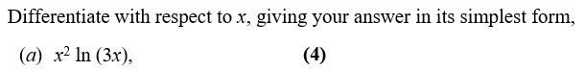

Edexcel C3 June 2013 Q5(c)

$$\frac{dy}{dx}=\frac{1}{6x{\left(x-1\right)}^{\frac{1}{2}}}$$

Find $\frac{d^{2}y}{dx^{2}}$, simplifying your answer.

Exercise 9D Page 242